**ANALYZING MOTOR VEHICLE COLLISIONS  
PROJECT REPORT**

**ABSTRACT:**

* The goal of the project is to leverage integrated crash data from the Department of Transportation portals in three major cities: Austin, Chicago, and New York. This effort aims to investigate the complexities of traffic crash incidents, their patterns, contributing variables, and subsequent effects on public safety, with the primary goal of improving urban traffic safety measures. This collaborative initiative highlights the need for a group effort to address pressing issues related to public safety and urban mobility.

**STEPS INVOLVED:**

* **Data Analysis and Profiling**: Using the profile tools Alteryx and Ydata, a thorough data profiling exercise is conducted at the beginning of the project. The team's goal is to obtain a deep understanding of the qualities, traits, and possible problems present in the crash data sets through painstaking study.
* **Structured Data Staging and ETL:** The project moves on to data staging using Talend ETL operations after data profiling. By following industry best practices, the team makes sure that the data is consistent and of high quality during the staging phase, which provides a solid basis for further research.  
  **Dimensional Modeling:** Creating a dimensional model that incorporates dimensions and facts is essential to the project's architecture. The group outlines the complex connections between source data columns and the associated destination entities through painstaking documentation and mapping operations, guaranteeing traceability and clarity all the way through the data transformation process.
* **Real-time Problem Solving:** The initiative addresses issues related to accident incidence, severity, contributing variables, and temporal patterns that are common in urban traffic safety in real-time. The team utilizes SQL queries on the dimensional data model to derive meaningful insights that can guide policy decisions and reduce the likelihood of traffic-related incidents.   
  **Visualization and Insights:** Utilizing cutting-edge technologies like Tableau and Power BI, the project moves into the visualization phase in its last phase. Stakeholders can get profound insights into the crash data analysis process through visually appealing representations. This allows for proactive interventions to support urban traffic safety measures and informed decision-making processes.

**DATA PROFILING AND GENERAL DOCUMENTATION OF DATASETS**

* **AUSTIN:**

There are 54 columns in this dataset.

|  |  |  |
| --- | --- | --- |
| **Column Name** | **Description** | **Type** |
| crash_id | TxDOT C.R.I.S. system-generated unique identifying number for a crash | Number |
| crash_fatal_fl | Fatal Crash Identifier - Indicates that the crash involved one or more fatalities | Plain Text |
| crash_date | Crash Date | Date & Time |
| crash_time | Crash Time - Time crash occurred | Plain Text |
| case_id | Case ID | Plain Text |
| rpt_latitude | Reported Latitude | Number |
| rpt_longitude | Reported Longitude | Number |
| rpt_block_num | Reported Block Number (road on which crash occurred) | Plain Text |
| rpt_street_pfx | Reported Street Prefix (road on which crash occurred) | Plain Text |
| rpt_street_name | Reported Street Name (road on which crash occurred) | Plain Text |
| rpt_street_sfx | Reported Street Suffix (road on which crash occurred) | Plain Text |
| crash_speed_limit | Speed Limit | Number |
| road_constr_zone_fl | Construction Zone - Indicates whether the crash occurred in or was related to a construction, maintenance, or utility work zone, regardless of whether workers were present at the time of the crash | Plain Text |
| latitude | Derived Latitude map coordinate of the crash | Number |
| longitude | Derived Longitude map coordinate of the crash | Number |
| street_name | Derived Street Name - Name of the road crash occurred on, as determined by the Locator application. | Plain Text |
| street_nbr | Derived Street Number - Block number of primary street where crash occurred as determined by the Locator application | Plain Text |
| street_name_2 | Derived Street Name 2 - The road name for the secondary road related to the crash location (If applicable) | Plain Text |
| street_nbr_2 | Derived Street Number 2 - Block number of secondary street related to the crash location as determined by the Locator application (If applicable) | Plain Text |
| crash_sev_id | Crash Severity - Most severe injury suffered by any one person involved in the crash (0=UNKNOWN, 1=INCAPACITATING INJURY, 2=NON-INCAPACITATING INJURY, 3=POSSIBLE INJURY, 4=KILLED, 5=NOT INJURED) | Number |
| sus_serious_injry_cnt | Total Suspected Serious Injury Count | Number |
| nonincap_injry_cnt | Total Non-incapacitating Injury Count | Number |
| poss_injry_cnt | Total Possible Injury Count | Number |
| non_injry_cnt | Total Not Injured Count | Number |
| unkn_injry_cnt | Total Unknown Injury Count | Number |
| tot_injry_cnt | Total Injury Count | Number |
| death_cnt | Total Death Count | Number |
| contrib_factr_p1_id | The first factor for a given vehicle which the officer felt possibly contributed to the crash | Plain Text |
| contrib_factr_p2_id | The second factor for a given vehicle which the officer felt possibly contributed to the crash | Plain Text |
| units_involved | Mode of units involved in crash | Plain Text |
| atd_mode_category_ metadata | Description of units involved in crash | Plain Text |
| pedestrian_fl | Pedestrian involved crash flag | Plain Text |
| motor_vehicle_fl | Motor vehicle involved crash flag | Plain Text |
| motorcycle_fl | Motorcycle involved crash flag | Plain Text |
| bicycle_fl | Bicyclist involved crash flag | Plain Text |
| other_fl | Other involved crash flag | Plain Text |
| point | Point datatype created with crash latitude and longitude to enable request of GeoJSON. | Point |
| apd_confirmed_fatality | APD Fatality flag | Plain Text |
| apd_confirmed_death_count | APD Fatality Count | Number |
| motor_vehicle_death_ count |  | Number |
| motor_vehicle_serious_ injury_count |  | Number |
| bicycle_death_count |  | Number |
| bicycle_serious_injury_count |  | Number |
| pedestrian_death_count |  | Number |
| pedestrian_serious_ injurycount |  | Number |
| motorcycle_death_ count |  | Number |
| motorcycle_serious_ injury_count |  | Number |
| other_death_count |  | Number |
| other_serious_injury_ count |  | Number |
| onsys_fl | Flag indicates whether primary road of crash was on the TxDOT highway system. | Plain Text |
| private_dr_fl | Flag indicating whether crash occurred on a private drive or road/private property/parking lot. | Plain Text |
| micromobility_serious_ injury_count |  | Number |
| micromobility_death_ count |  | Number |
| micromobility_fl |  | Plain Text |

**Dataset Statistics:**

Number of Variables: **54**

Number of Observations: **147,750**

Missing Cells: **1,725,084**

Missing Cells (%): **21.6%**

Duplicate Rows: **0**

Duplicate Rows (%): **0.0%**

Total Size in Memory: **60.9 MiB**

Average Record Size in Memory: **432.0 B**

**Variable Types:**

Numeric: **17 |** Boolean: **11 |** Date Time: **2 |** Text: **8 |** Categorical: **15 |** Unsupported: **1**

**Missing Values:**

The following columns have missing values which have to be handled using appropriate handling methods:

* case_id has 1858(1.3%)
* point has 2243 (1.5%)
* latitude has 2243 (1.5%)
* longitude has 2243 (1.5%)
* rpt_block_num has 19611 (13.3%)
* rpt_street_sfx has 50340 (34.1%)
* rpt_street_pfx has 67805 (45.9%)
* street_name_2 has 81474 (55.1%)
* street_nbr has 87038 (58.9%)
* contrib_factr_p1_id has 119143 (80.6%)
* rpt_latitude has 137456 (93.0%)
* rpt_longitude has 137456 (93.0%)
* other_fl has 142905 (96.7%)
* contrib_factr_p2_id has 143235 (96.9%)
* pedestrian_fl has 144245 (97.6%)
* motorcycle_fl has 144148 (97.6%)
* bicycle_fl has 145306 (98.3%)
* micromobility_fl has 147439 (99.8%)
* street_nbr_2 has 147750 (100.0%)

**Observations:**

* **case_id** has the least number of missing values and **street_nbr_2** has the greatest number of missing values.
* **street_nbr_2**has no values in any of the rows, it is in an unsupported datatype format. Since it has no values, the column can also be completely dropped.
* **crash_id**has unique values and is a good fit for primary key.
* **crash_date** contains both the crash date and time. But there is also a separate **crash_time** column that contains the time of accident. crash_time must be deleted or crash_date must be handled to separate the crash_time from it.
* The **crash_date** column ranges from 03/26/2014 to 03/11/2024, indicating no discrepancies in the dates being reported after the date of analysis.
* Most columns have generic datatypes which must be handled. For example, all the flag values are stored as plain text, but the best practice is to convert them as Boolean. The same has to be cross verified and appropriate steps to handle data types must be taken.

**Alteryx Workflow with the profiling run statistics:**

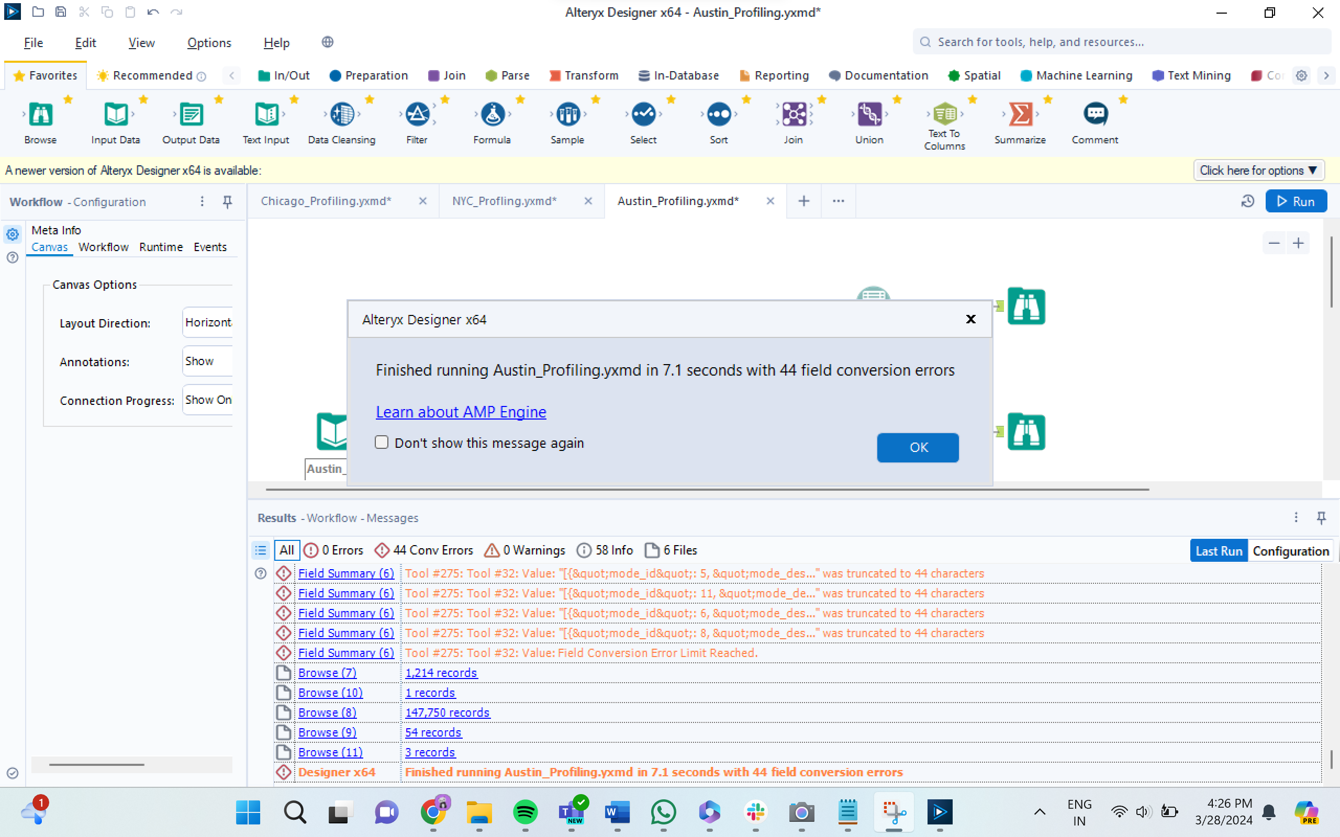

**REPORT:**

**Numeric Fields:**

|  |  |  |  |  |  |  |  |  |
| --- | --- | --- | --- | --- | --- | --- | --- | --- |
| **Name** | **% Missing** | **Unique Values** | **Min** | **Mean** | **Median** | **Max** | **Std Dev** | **Remarks** |
| apd_confirmed_death_count | 0.0% | 5 | 0.000 | 0.006 | 0.000 | 4.000 | 0.082 | This field has a small number of unique values and appears to be a categorical field. Consider changing the field data type to "string". |
| micromobility_death_count | 0.0% | 2 | 0.000 | 0.000 | 0.000 | 1.000 | 0.006 | This field has a small number of unique values and appears to be a categorical field. Consider changing the field data type to "string". |
| rpt_latitude | 93.0% | 7,977 | 25.837 | 30.297 | 30.295 | 36.500 | 0.377 | This field has over 10% missing values. Consider imputing these values. |
| sus_serious_ injry_cnt | 0.0% | 7 | 0.000 | 0.034 | 0.000 | 10.000 | 0.207 | This field has a small number of unique values and appears to be a categorical field. Consider changing the field data type to "string". |
| motor_vehicle_serious_injury_count | 0.0% | 6 | 0.000 | 0.023 | 0.000 | 5.000 | 0.176 | This field has a small number of unique values and appears to be a categorical field. Consider changing the field data type to "string". |
| contrib_factr_ p2_id | 96.9% | 66 | 1.000 | 36.347 | 22.000 | 79.000 | 20.583 | This field has over 10% missing values. Consider imputing these values. |
| motorcycle_ death_count | 0.0% | 3 | 0.000 | 0.001 | 0.000 | 2.000 | 0.030 | This field has a small number of unique values and appears to be a categorical field. Consider changing the field data type to "string". |
| motorcycle_ serious_injury_count | 0.0% | 3 | 0.000 | 0.005 | 0.000 | 2.000 | 0.071 | This field has a small number of unique values and appears to be a categorical field. Consider changing the field data type to "string". |
| other_death_ count | 0.0% | 1 | 0.000 | 0.000 | 0.000 | 0.000 | 0.000 | This field has a small number of unique values and appears to be a categorical field. Consider changing the field data type to "string". |
| contrib_factr_ p1_id | 80.6% | 71 | 1.000 | 33.358 | 20.000 | 80.000 | 19.899 | This field has over 10% missing values. Consider imputing these values. |
| pedestrian_ death_count | 0.0% | 3 | 0.000 | 0.002 | 0.000 | 2.000 | 0.047 | This field has a small number of unique values and appears to be a categorical field. Consider changing the field data type to "string". |
| rpt_longitude | 93.0% | 7,265 | -106.646 | -97.747 | -97.731 | -93.508 | 0.537 | This field has over 10% missing values. Consider imputing these values. |
| pedestrian_ serious_injury_count | 0.0% | 5 | 0.000 | 0.004 | 0.000 | 9.000 | 0.071 | This field has a small number of unique values and appears to be a categorical field. Consider changing the field data type to "string". |
| bicycle_serious_injury_count | 0.0% | 4 | 0.000 | 0.002 | 0.000 | 3.000 | 0.043 | This field has a small number of unique values and appears to be a categorical field. Consider changing the field data type to "string". |
| micromobility_serious_injury_count | 0.0% | 3 | 0.000 | 0.000 | 0.000 | 2.000 | 0.018 | This field has a small number of unique values and appears to be a categorical field. Consider changing the field data type to "string". |
| motor_vehicle_death_count | 0.0% | 5 | 0.000 | 0.003 | 0.000 | 4.000 | 0.059 | This field has a small number of unique values and appears to be a categorical field. Consider changing the field data type to "string". |
| bicycle_death_count | 0.0% | 2 | 0.000 | 0.000 | 0.000 | 1.000 | 0.014 | This field has a small number of unique values and appears to be a categorical field. Consider changing the field data type to "string". |
| other_serious_injury_count | 0.0% | 3 | 0.000 | 0.000 | 0.000 | 3.000 | 0.009 | This field has a small number of unique values and appears to be a categorical field. Consider changing the field data type to "string". |
| death_cnt | 0.0% | 5 | 0.000 | 0.006 | 0.000 | 4.000 | 0.082 | This field has a small number of unique values and appears to be a categorical field. Consider changing the field data type to "string". |
| crash_sev_id | 0.0% | 8 | 0.000 | 3.707 | 5.000 | 99.000 | 1.754 | This field has a small number of unique values and appears to be a categorical field. Consider changing the field data type to "string". |
| unkn_injry_cnt | 0.0% | 17 | 0.000 | 0.116 | 0.000 | 41.000 | 0.418 |  |
| poss_injry_cnt | 0.0% | 17 | 0.000 | 0.339 | 0.000 | 20.000 | 0.728 |  |
| crash_speed_limit | 0.0% | 29 | -1.000 | 34.758 | 40.000 | 85.000 | 23.233 |  |
| crash_id | 0.0% | 147,750 | 1,001.000 | 16,810,778.317 | 16,758,228.500 | 180,290,542.000 | 1,832,197.355 |  |
| tot_injry_cnt | 0.0% | 19 | 0.000 | 0.642 | 0.000 | 21.000 | 0.935 |  |
| non_injry_cnt | 0.0% | 47 | 0.000 | 1.850 | 2.000 | 56.000 | 1.637 |  |
| nonincap_injry_cnt | 0.0% | 15 | 0.000 | 0.269 | 0.000 | 14.000 | 0.625 |  |

**Date Fields:**

|  |  |  |  |  |  |  |
| --- | --- | --- | --- | --- | --- | --- |
| **Name** | **% Missing** | **Unique Values** | **Latest Date** | **Earliest Date** | **Interval** | **Remarks** |
| crash_time | 0.0% | 1,440 | 01/01/1400 23:00 | 01/01/1400 00:00 | Unknown |  |

**String/Character Fields:**

|  |  |  |  |  |  |  |  |
| --- | --- | --- | --- | --- | --- | --- | --- |
| **Name** | **% Missing** | **Unique Values** | **Shortest Value** | **Longest Value** | **Min Value Count** | **Max Value Count** | **Remarks** |
| pedestrian_fl | 97.6% | 2 | Y | Y | 3,505 | 144,245 | This field has over 10% missing values. Consider imputing these values. Some values of this field have a small number of value counts. If Appropriate, consider combining some value levels together. |
| bicycle_fl | 98.3% | 2 | Y | Y | 2,444 | 145,306 | This field has over 10% missing values. Consider imputing these values. Some values of this field have a small number of value counts. If Appropriate, consider combining some value levels together. |
| motorcycle_fl | 97.6% | 2 | Y | Y | 3,602 | 144,148 | This field has over 10% missing values. Consider imputing these values. Some values of this field have a small number of value counts. If Appropriate, consider combining some value levels together. |
| crash_fatal_fl | 0.0% | 2 | N | N | 866 | 146,884 | Some values of this field have a small number of value counts. If Appropriate, consider combining some value levels together. |
| latitude | 1.5% | 96,362 | 30.4 | 30.368659130525828 | 1 | 2,243 | Some values of this field have a small number of value counts. If Appropriate, consider combining some value levels together. |
| motor_vehicle_fl | 0.8% | 2 | Y | Y | 1,116 | 146,634 | Some values of this field have a small number of value counts. If Appropriate, consider combining some value levels together. |
| case_id | 1.3% | 145,679 | . | 10000 BLK US HIGHWAY | 1 | 1,858 | Some values of this field have a small number of value counts. If Appropriate, consider combining some value levels together. |
| longitude | 1.5% | 96,265 | -97.767 | -97.69380787510062 | 1 | 2,243 | Some values of this field have a small number of value counts. If Appropriate, consider combining some value levels together. |
| micromobility_fl | 99.8% | 2 | Y | Y | 311 | 147,439 | This field has over 10% missing values. Consider imputing these values. Some values of this field have a small number of value counts. If Appropriate, consider combining some value levels together. |
| road_constr_ zone_fl | 0.0% | 3 | N | N | 2 | 139,901 | Some values of this field have a small number of value counts. If Appropriate, consider combining some value levels together. |
| other_fl | 96.7% | 2 | Y | Y | 4,845 | 142,905 | This field has over 10% missing values. Consider imputing these values. Some values of this field have a small number of value counts. If Appropriate, consider combining some value levels together. |
| point | 1.5% | 97,740 | POINT (-97.65954 30.4) | POINT (-97.69380787510062 30.368659130525828) | 1 | 2,243 | Some values of this field have a small number of value counts. If Appropriate, consider combining some value levels together. |
| units_involved | 0.0% | 1,113 | Motorcycle | Other/Unknown & Passenger car & Passenger car & Large passenger vehicle & Large passenger vehicle & Large passenger vehicle & Large passenger vehicle & Passenger car & Motor vehicle â€“other & Large passenger vehicle & Passenger car & Other/Unknown & Pa | 1 | 34,141 | Some values of this field have a small number of value counts. If Appropriate, consider combining some value levels together. |
| street_name_2 | 0.0% | 3,398 | N/A | E ANDERSON EB TO N 35 SB RAMPN IH35 SB | 1 | 81,472 | Some values of this field have a small number of value counts. If Appropriate, consider combining some value levels together. |
| street_name | 0.0% | 4,631 | 441 | PRIVATE DRIVE TO THE CATHERINE APARTMENTS | 1 | 24,841 | Some values of this field have a small number of value counts. If Appropriate, consider combining some value levels together. |
| rpt_street_pfx | 45.9% | 9 | W | SW | 30 | 67,805 | This field has over 10% missing values. Consider imputing these values. Some values of this field have a small number of value counts. If Appropriate, consider combining some value levels together. |
| crash_date | 0.0% | 144,667 | 03/30/2014 10:58:00 AM | 03/30/2014 10:58:00 AM | 1 | 4 | Some values of this field have a small number of value counts. If Appropriate, consider combining some value levels together. |
| street_nbr | 58.9% | 9,828 | 0 | 11099 | 1 | 86,964 | This field has over 10% missing values. Consider imputing these values. Some values of this field have a small number of value counts. If Appropriate, consider combining some value levels together. |
| rpt_street_name | 0.0% | 9,796 | 1 | ED BLUESTEIN BLVD SB TO ED BLUESTEIN BLVD SVRD SB | 1 | 10,178 | Some values of this field have a small number of value counts. If Appropriate, consider combining some value levels together. |
| rpt_block_num | 13.3% | 4,789 | E | 11100 BLK | 1 | 19,611 | This field has over 10% missing values. Consider imputing these values. Some values of this field have a small number of value counts. If Appropriate, consider combining some value levels together. |
| apd_confirmed_fatality | 0.0% | 2 | N | N | 842 | 146,908 | Some values of this field have a small number of value counts. If Appropriate, consider combining some value levels together. |
| rpt_street_sfx | 34.1% | 19 | RD | BLVD | 40 | 50,340 | This field has over 10% missing values. Consider imputing these values. Some values of this field have a small number of value counts. If Appropriate, consider combining some value levels together. |
| atd_mode_category_metadata | 0.0% | 147,744 | [{"mode_id": 3, "mode_desc": "Motorcycle", "unit_id": 2262910, "death_cnt": 0, "sus_serious_injry_cnt": 0, "nonincap_injry_cnt": 0, "poss_injry_cnt": 0, "non_injry_cnt": 1, "unkn_injry_cnt": 0, "tot_injry_cnt": 0}] | [{"mode_id": 1, "mode_desc": "Passenger car", "unit_id": 2262335, "death_cnt": 0, "sus_serious_injry_cnt": 0, "nonincap_injry_cnt": 0, "poss_injry_cnt": 0, "non_injry_cnt": 1, "unkn_injry_cnt": 0, "tot_injry_cnt": 0}, {"mode_id": 1, "mode_desc": "Passeng | 1 | 7 | Some values of this field have a small number of value counts. If Appropriate, consider combining some value levels together. |
| private_dr_fl | 0.0% | 1 | N | N | 147,750 | 147,750 |  |
| onsys_fl | 0.0% | 2 | N | N | 73,041 | 74,709 |  |

* **CHICAGO:**

There are 48 columns in this dataset.

|  |  |  |  |
| --- | --- | --- | --- |
| **Column name** | **Description** | **Type** | **Data Type** |
| crash_record_id | This number can be used to link to the same crash in the Vehicles and People datasets. This number also serves as a unique ID in this dataset. | Plain Text | String |
| crash_date_est_i | Crash date estimated by desk officer or reporting party (only used in cases where crash is reported at police station days after the crash) | Plain Text | String |
| crash_date | Date and time of crash as entered by the reporting officer | Date & Time | Date |
| posted_speed_ limit | Posted speed limit, as determined by reporting officer | Number | Int |
| traffic_control_ device | Traffic control device present at crash location, as determined by reporting officer | Plain Text | String |
| device_condition | Condition of traffic control device, as determined by reporting officer | Plain Text | String |
| weather_ condition | Weather condition at time of crash, as determined by reporting officer | Plain Text | String |
| lighting_ condition | Light condition at time of crash, as determined by reporting officer | Plain Text | String |
| first_crash_ type | Type of first collision in crash | Plain Text | String |
| trafficway_type | Trafficway type, as determined by reporting officer | Plain Text | String |
| lane_cnt | Total number of through lanes in either direction, excluding turn lanes, as determined by reporting officer (0 = intersection) | Number | Int |
| alignment | Street alignment at crash location, as determined by reporting officer | Plain Text | String |
| roadway_ surface_cond | Road surface condition, as determined by reporting officer | Plain Text | String |
| road_defect | Road defects, as determined by reporting officer | Plain Text | String |
| report_type | Administrative report type (at scene, at desk, amended) | Plain Text | String |
| crash_type | A general severity classification for the crash. Can be either Injury and/or Tow Due to Crash or No Injury / Drive Away | Plain Text | String |
| intersection_ related_i | A field observation by the police officer whether an intersection played a role in the crash. Does not represent whether or not the crash occurred within the intersection. | Plain Text | String |
| not_right_of_way_i | Whether the crash begun, or first contact was made outside of the public right-of-way. | Plain Text | String |
| hit_and_run_i | Crash did/did not involve a driver who caused the crash and fled the scene without exchanging information and/or rendering aid | Plain Text | String |
| damage | A field observation of estimated damage. | Plain Text | String |
| date_police_ notified | Calendar date on which police were notified of the crash | Date & Time | String |
| prim_contributory_cause | The factor, which was most significant in causing the crash, as determined by officer judgment | Plain Text | String |
| sec_contributory_cause | The factor, which was second most significant in causing the crash, as determined by officer judgment | Plain Text | String |
| street_no | Street address number of crash location, as determined by reporting officer | Number | Int |
| street_direction | Street address direction (N, E,S,W) of crash location, as determined by reporting officer | Plain Text | Int |
| street_name | Street address name of crash location, as determined by reporting officer | Plain Text | String |
| beat_of_ occurrence | [Chicago Police Department Beat ID. Boundaries available at https://data.cityofchicago.org/d/aerh-rz74](https://data.cityofchicago.org/d/aerh-rz74) | Number | String |
| photos_taken_i | Whether the Chicago Police Department took photos at the location of the crash | Plain Text | String |
| statements_taken_i | Whether statements were taken from unit(s) involved in crash | Plain Text | String |
| dooring_i | Whether crash involved a motor vehicle occupant opening a door into the travel path of a bicyclist, causing a crash | Plain Text | String |
| work_zone_i | Whether the crash occurred in an active work zone | Plain Text | String |
| work_zone_type | The type of work zone if any | Plain Text | String |
| workers_present_i | Whether construction workers were present in an active work zone at crash location | Plain Text | String |
| num_units | Number of units involved in the crash. A unit can be a motor vehicle, a pedestrian, a bicyclist, or another non-passenger roadway user. Each unit represents a mode of traffic with an independent trajectory. | Number | Int |
| most_severe_ injury | Most severe injury sustained by any person involved in the crash | Plain Text | String |
| injuries_total | Total persons sustaining fatal, incapacitating, non-incapacitating, and possible injuries as determined by the reporting officer | Number | Int |
| injuries_fatal | Total persons sustaining fatal injuries in the crash | Number | Int |
| injuries_ incapacitating | Total persons sustaining incapacitating/serious injuries in the crash as determined by the reporting officer. Any injury other than fatal injury, which prevents the injured person from walking, driving, or normally continuing the activities they could perform before the injury occurred. Includes severe lacerations, broken limbs, skull or chest injuries, and abdominal injuries. | Number | Int |
| injuries_non_ incapacitating | Total persons sustaining non-incapacitating injuries in the crash as determined by the reporting officer. Any injury, other than fatal or incapacitating injury, which is evident to observers at the scene of the crash. Includes lump on head, abrasions, bruises, and minor lacerations. | Number | Int |
| injuries_reported_not_evident | Total persons sustaining possible injuries in the crash as determined by the reporting officer. Includes momentary unconsciousness, claims of injuries not evident, limping, complaint of pain, nausea, and hysteria. | Number | Int |
| injuries_no_ indication | Total persons sustaining no injuries in the crash as determined by the reporting officer | Number | Int |
| injuries_unknown | Total persons for whom injuries sustained, if any, are unknown | Number | Int |
| crash_hour | The hour of the day component of CRASH_DATE. | Number | Int |
| crash_day_of_ week | The day of the week component of CRASH_DATE. Sunday=1 | Number | Int |
| crash_month | The month component of CRASH_DATE. | Number | Int |
| latitude | The latitude of the crash location, as determined by reporting officer, as derived from the reported address of crash | Number | Int |
| longitude | The longitude of the crash location, as determined by reporting officer, as derived from the reported address of crash | Number | Int |
| location | The crash location, as determined by reporting officer, as derived from the reported address of crash, in a column type that allows for mapping and other geographic analysis in the data portal software | Point | Float/Double |

**Dataset statistics:**

Number of variables: **48**

Number of observations: **817723**

Missing cells: **8268003**

Missing cells (%): **21.1%**

Duplicate rows: **0**

Duplicate rows (%): **0.0%**

Total size in memory: **299.5 MiB**

Average record size in memory: **384.0 B**

**Variable types:**

Text: **3** | Boolean: **9** | Date Time: **2** | Numeric: **15** | Categorical: **19**

**Missing values:**

The following columns have missing values:

report_type 24314 (3.0%)

hit_and_run_i 561774 (68.7%)

lane_cnt 618714 (75.7%)

intersection_related_i 630174 (77.1%)

crash_date_est_i 756594 (92.5%)

not_right_of_way_i 780015 (95.4%)

statements_taken_i 799465 (97.8%)

photos_taken_I 806948 (98.7%)

work_zone_i 813053 (99.4%)

work_zone_type 814105 (99.6%)

dooring_i 815211 (99.7%)

workers_present_i 816529 (99.9%)

**Observations:**

* **report_type** has the least number of missing values and **workers_present_i** has the greatest number of missing values.
* **crash_record_id** has unique values and is a good fit for primary key.
* **crash_date** contains both the crash date and time. crash_date must be handled to separate the crash_time from it.
* The **crash_date** column ranges from 03/03/2013 to 03/26/2024, indicating no discrepancies in the dates being reported after the date of analysis.

**Alteryx Workflow with the profiling run statistics:**

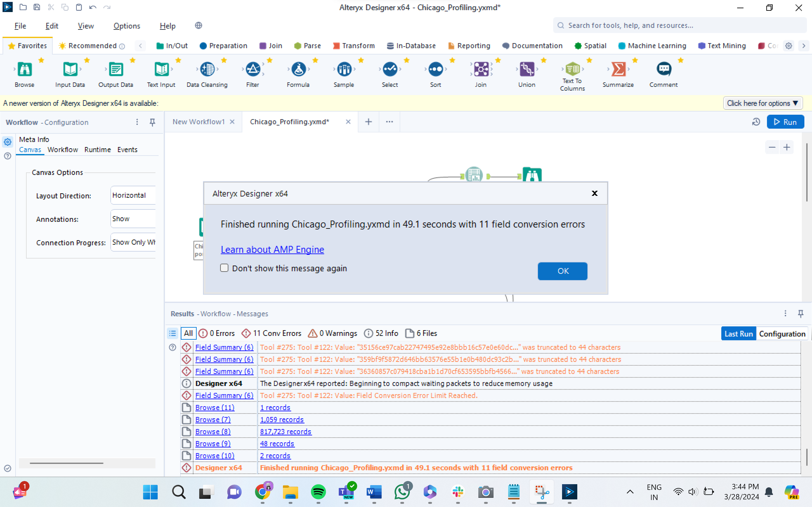

**REPORT:**

**Numeric Fields:**

|  |  |  |  |  |  |  |  |  |
| --- | --- | --- | --- | --- | --- | --- | --- | --- |
| **Name** | **% Missing** | **Unique Values** | **Min** | **Mean** | **Median** | **Max** | **Std Dev** | **Remarks** |
| lane_cnt | 75.7% | 42 | 0.000 | 13.330 | 2.000 | 1,191,625.000 | 2,961.601 | This field has over 10% missing values. Consider imputing these values. |
| injuries_fatal | 0.2% | 6 | 0.000 | 0.001 | 0.000 | 4.000 | 0.037 | This field has a small number of unique values and appears to be a categorical field. Consider changing the field data type to "string". |
| injuries_ unknown | 0.2% | 2 | 0.000 | 0.000 | 0.000 | 0.000 | 0.000 | This field has a small number of unique values and appears to be a categorical field. Consider changing the field data type to "string". |
| crash_day_ of_week | 0.0% | 7 | 1.000 | 4.123 | 4.000 | 7.000 | 1.981 | This field has a small number of unique values and appears to be a categorical field. Consider changing the field data type to "string". |
| injuries_no_ indication | 0.2% | 49 | 0.000 | 2.003 | 2.000 | 61.000 | 1.157 |  |
| longitude | 0.7% | 300,055 | -87.936 | -87.674 | -87.674 | 0.000 | 0.684 |  |
| num_units | 0.0% | 17 | 1.000 | 2.035 | 2.000 | 18.000 | 0.453 |  |
| street_no | 0.0% | 11,728 | 0.000 | 3,689.634 | 3,201.000 | 451,100.000 | 2,886.884 |  |
| latitude | 0.7% | 300,092 | 0.000 | 41.855 | 41.875 | 42.023 | 0.336 |  |
| beat_of_ occurrence | 0.0% | 277 | 111.000 | 1,243.735 | 1,212.000 | 6,100.000 | 705.271 |  |
| injuries_reported_not_evident | 0.2% | 14 | 0.000 | 0.062 | 0.000 | 15.000 | 0.319 |  |
| crash_month | 0.0% | 12 | 1.000 | 6.656 | 7.000 | 12.000 | 3.453 |  |
| injuries_non_ incapacitating | 0.2% | 20 | 0.000 | 0.107 | 0.000 | 21.000 | 0.422 |  |
| crash_hour | 0.0% | 24 | 0.000 | 13.198 | 14.000 | 23.000 | 5.570 |  |
| injuries_ incapacitating | 0.2% | 11 | 0.000 | 0.020 | 0.000 | 10.000 | 0.165 |  |
| injuries_total | 0.2% | 21 | 0.000 | 0.190 | 1.000 | 21.000 | 0.566 |  |
| posted_speed_ limit | 0.0% | 46 | 0.000 | 28.406 | 30.000 | 99.000 | 6.166 |  |

**String/Character Fields:**

|  |  |  |  |  |  |  |  |
| --- | --- | --- | --- | --- | --- | --- | --- |
| **Name** | **% Missing** | **Unique Values** | **Shortest Value** | **Longest Value** | **Min Value Count** | **Max Value Count** | **Remarks** |
| weather_ condition | 0.0% | 12 | SNOW | BLOWING SAND, SOIL, DIRT | 7 | 641,373 | Some values of this field have a small number of value counts. If Appropriate, consider combining some value levels together. |
| date_police_ notified | 0.0% | 620,545 | 09/05/2023 07:05:00 PM | 09/05/2023 07:05:00 PM | 1 | 12 | Some values of this field have a small number of value counts. If Appropriate, consider combining some value levels together. |
| crash_date_est_i | 92.5% | 3 | Y | Y | 7,862 | 756,594 | This field has over 10% missing values. Consider imputing these values. Some values of this field have a small number of value counts. If Appropriate, consider combining some value levels together. |
| lighting_ condition | 0.0% | 6 | DUSK | DARKNESS, LIGHTED ROAD | 13,689 | 522,973 | Some values of this field have a small number of value counts. If Appropriate, consider combining some value levels together. |
| dooring_i | 99.7% | 3 | Y | Y | 824 | 815,211 | This field has over 10% missing values. Consider imputing these values. Some values of this field have a small number of value counts. If Appropriate, consider combining some value levels together. |
| road_defect | 0.0% | 7 | OTHER | DEBRIS ON ROADWAY | 616 | 657,425 | Some values of this field have a small number of value counts. If Appropriate, consider combining some value levels together. |
| street_name | 0.0% | 1,642 | 82ND | MICHIGAN AVE 175 E CHESTNUT AVE | 1 | 22,319 | Some values of this field have a small number of value counts. If Appropriate, consider combining some value levels together. |
| crash_record_ id | 0.0% | 817,723 | 23a79931ef555d54118f64dc9be2cf2dbf59636ce253f7a1179c4a1c091442a6eeab8352220c7c56ca1ff7c4b4b0fc345c74e3e85ecb9d43deeb66b5f803d4a0 | 23a79931ef555d54118f64dc9be2cf2dbf59636ce253f7a1179c4a1c091442a6eeab8352220c7c56ca1ff7c4b4b0fc345c74e3e85ecb9d43deeb66b5f803d4a0 | 1 | 1 | Some values of this field have a small number of value counts. If Appropriate, consider combining some value levels together. |
| first_crash_type | 0.0% | 18 | ANGLE | SIDESWIPE OPPOSITE DIRECTION | 45 | 190,062 | Some values of this field have a small number of value counts. If Appropriate, consider combining some value levels together. |
| report_type | 3.0% | 4 | AMENDED | NOT ON SCENE (DESK REPORT) | 240 | 447,696 | Some values of this field have a small number of value counts. If Appropriate, consider combining some value levels together. |
| trafficway_type | 0.0% | 20 | RAMP | DIVIDED - W/MEDIAN (NOT RAISED) | 168 | 355,079 | Some values of this field have a small number of value counts. If Appropriate, consider combining some value levels together. |
| statements_takn_i | 97.8% | 3 | Y | Y | 3,384 | 799,465 | This field has over 10% missing values. Consider imputing these values. Some values of this field have a small number of value counts. If Appropriate, consider combining some value levels together. |
| crash_date | 0.0% | 536,888 | 09/05/2023 07:05:00 PM | 09/05/2023 07:05:00 PM | 1 | 30 | Some values of this field have a small number of value counts. If Appropriate, consider combining some value levels together. |
| street_direction | 0.0% | 5 | S | S | 4 | 292,260 | Some values of this field have a small number of value counts. If Appropriate, consider combining some value levels together. |
| alignment | 0.0% | 6 | CURVE, LEVEL | STRAIGHT ON HILLCREST | 364 | 797,888 | Some values of this field have a small number of value counts. If Appropriate, consider combining some value levels together. |
| traffic_control_device | 0.0% | 19 | OTHER | PEDESTRIAN CROSSING SIGN | 25 | 464,816 | Some values of this field have a small number of value counts. If Appropriate, consider combining some value levels together. |
| location | 0.7% | 300,266 | POINT (0 0) | POINT (-87.665902342962 41.854120262952) | 1 | 5,615 | Some values of this field have a small number of value counts. If Appropriate, consider combining some value levels together. |
| hit_and_run_i | 68.7% | 3 | Y | Y | 10,994 | 561,774 | This field has over 10% missing values. Consider imputing these values. Some values of this field have a small number of value counts. If Appropriate, consider combining some value levels together. |
| work_zone_i | 99.4% | 3 | Y | Y | 1,052 | 813,053 | This field has over 10% missing values. Consider imputing these values. Some values of this field have a small number of value counts. If Appropriate, consider combining some value levels together. |
| photos_taken_i | 98.7% | 3 | Y | Y | 2,665 | 806,948 | This field has over 10% missing values. Consider imputing these values. Some values of this field have a small number of value counts. If Appropriate, consider combining some value levels together. |
| device_condition | 0.0% | 8 | OTHER | WORN REFLECTIVE MATERIAL | 95 | 470,240 | Some values of this field have a small number of value counts. If Appropriate, consider combining some value levels together. |
| most_severe_ injury | 0.2% | 6 | FATAL | NONINCAPACITATING INJURY | 899 | 703,419 | Some values of this field have a small number of value counts. If Appropriate, consider combining some value levels together. |
| not_right_of_way_i | 95.4% | 3 | Y | Y | 3,452 | 780,015 | This field has over 10% missing values. Consider imputing these values. Some values of this field have a small number of value counts. If Appropriate, consider combining some value levels together. |
| sec_contributory_cause | 0.0% | 40 | ANIMAL | OPERATING VEHICLE IN ERRATIC, RECKLESS, CARELESS, NEGLIGENT OR AGGRESSIVE MANNER | 56 | 335,814 | Some values of this field have a small number of value counts. If Appropriate, consider combining some value levels together. |
| prim_contributory_cause | 0.0% | 40 | ANIMAL | OPERATING VEHICLE IN ERRATIC, RECKLESS, CARELESS, NEGLIGENT OR AGGRESSIVE MANNER | 23 | 318,311 | Some values of this field have a small number of value counts. If Appropriate, consider combining some value levels together. |
| intersection_related_i | 77.1% | 3 | Y | Y | 8,907 | 630,174 | This field has over 10% missing values. Consider imputing these values. Some values of this field have a small number of value counts. If Appropriate, consider combining some value levels together. |
| workers_present_i | 99.9% | 3 | Y | Y | 138 | 816,529 | This field has over 10% missing values. Consider imputing these values. Some values of this field have a small number of value counts. If Appropriate, consider combining some value levels together. |
| work_zone_type | 99.6% | 5 | UTILITY | CONSTRUCTION | 228 | 814,105 | This field has over 10% missing values. Consider imputing these values. Some values of this field have a small number of value counts. If Appropriate, consider combining some value levels together. |
| roadway_surface_cond | 0.0% | 7 | DRY | SAND, MUD, DIRT | 303 | 603,295 | Some values of this field have a small number of value counts. If Appropriate, consider combining some value levels together. |
| damage | 0.0% | 3 | OVER $1,500 | $501 - $1,500 | 93,373 | 507,718 |  |
| crash_type | 0.0% | 2 | NO INJURY / DRIVE AWAY | INJURY AND / OR TOW DUE TO CRASH | 218,340 | 599,383 |  |

* **NYC:**

There are 28 columns in this dataset.

|  |  |  |  |
| --- | --- | --- | --- |
| **Column name** | **Description** | **Type** | **Data Type** |
| crash date | Occurrence date of collision | Date & Time | Date |
| crash time | Occurrence time of collision | Plain Text | String |
| borough | Borough where collision occurred | Plain Text | String |
| zip code | Postal code of incident occurrence | Plain Text | String |
| latitude | Latitude coordinate for Global Coordinate System, WGS 1984, decimal degrees (EPSG 4326) | Number | Int |
| longitude | Longitude coordinate for Global Coordinate System, WGS 1984, decimal degrees (EPSG 4326) | Number | Int |
| location | Latitude, Longitude pair | Location | Float/Double |
| on street name | Street on which the collision occurred | Plain Text | String |
| cross street name | Nearest cross street to the collision | Plain Text | String |
| off street name | Street address if known | Plain Text | String |
| number of persons injured | Number of persons injured | Number | Int |
| number of persons killed | Number of persons killed | Number | Int |
| number of pedestrians injured | Number of pedestrians injured | Number | Int |
| number of pedestrians killed | Number of pedestrians killed | Number | Int |
| number of cyclists injured | Number of cyclists injured | Number | Int |
| number of cyclists killed | Number of cyclists killed | Number | Int |
| number of motorists injured | Number of vehicle occupants injured | Number | Int |
| number of motorists killed | Number of vehicle occupants killed | Number | Int |
| contributing factor vehicle 1 | Factors contributing to the collision for designated vehicle | Plain Text | String |
| contributing factor vehicle 2 | Factors contributing to the collision for designated vehicle | Plain Text | String |
| contributing factor vehicle 3 | Factors contributing to the collision for designated vehicle | Plain Text | String |
| contributing factor vehicle 4 | Factors contributing to the collision for designated vehicle | Plain Text | String |
| contributing factor vehicle 5 | Factors contributing to the collision for designated vehicle | Plain Text | String |
| collision_id | Unique record code generated by system. Primary Key for Crash table. | Number | Int |
| vehicle type code 1 | Type of vehicle based on the selected vehicle category (ATV, bicycle, car/suv, ebike, escooter, truck/bus, motorcycle, other) | Plain Text | String |
| vehicle type code 2 | Type of vehicle based on the selected vehicle category (ATV, bicycle, car/suv, ebike, escooter, truck/bus, motorcycle, other) | Plain Text | String |
| vehicle type code 3 | Type of vehicle based on the selected vehicle category (ATV, bicycle, car/suv, ebike, escooter, truck/bus, motorcycle, other) | Plain Text | String |
| vehicle type code 4 | Type of vehicle based on the selected vehicle category (ATV, bicycle, car/suv, ebike, escooter, truck/bus, motorcycle, other) | Plain Text | String |
| vehicle type code 5 | Type of vehicle based on the selected vehicle category (ATV, bicycle, car/suv, ebike, escooter, truck/bus, motorcycle, other) | Plain Text | String |

1. **Profiling using Y-data profile.**

**Dataset statistics**:

Number of variables: **29**

Number of observations: **2075427**

Missing cells: **17761579**

Missing cells (%): **29.5%**

Duplicate rows: **0**

Duplicate rows (%): **0.0%**

Total size in memory: **459.2 MiB**

Average record size in memory: **232.0 B**

**Variable types:**

Date Time: **2 |** Categorical: **6** | Text: **13** | Numeric: **8**

**Missing values:**

* latitude has 233626 (11.3%)
* longitude has 233626 (11.3%)
* location has 233626 (11.3%)
* contributing factor vehicle 2 has 321736 (15.5%)
* vehicle type code 2 has 396691 (19.1%)
* on street name has 440569 (21.2%)
* borough has 645746 (31.1%)
* zip code has 645996 (31.1%)
* cross street name has 784436 (37.8%)
* off street name has 1727231 (83.2%)
* contributing factor vehicle 3 has 1927163 (92.9%)
* vehicle type code 3 has 1932530 (93.1%)
* contributing factor vehicle 4 has 2041953 (98.4%)
* vehicle type code 4 has 2043115 (98.4%)
* contributing factor vehicle 5 has 2066358 (99.6%)
* vehicle type code 5 has 2066635 (99.6%)

**Observations:**

* **Latitude, Longitude, and location** have the least number of missing values and **contributing factor vehicle 5 and vehicle type code 5** has the greatest number of missing values.
* **collision_id**has unique values and is a good fit for primary key.
* The **crash_date** column ranges from 7/27/2012 to 03/07/2024, indicating no discrepancies in the dates being reported after the date of analysis.

1. **Using Alteryx**

**Alteryx Workflow with the profiling run statistics:**

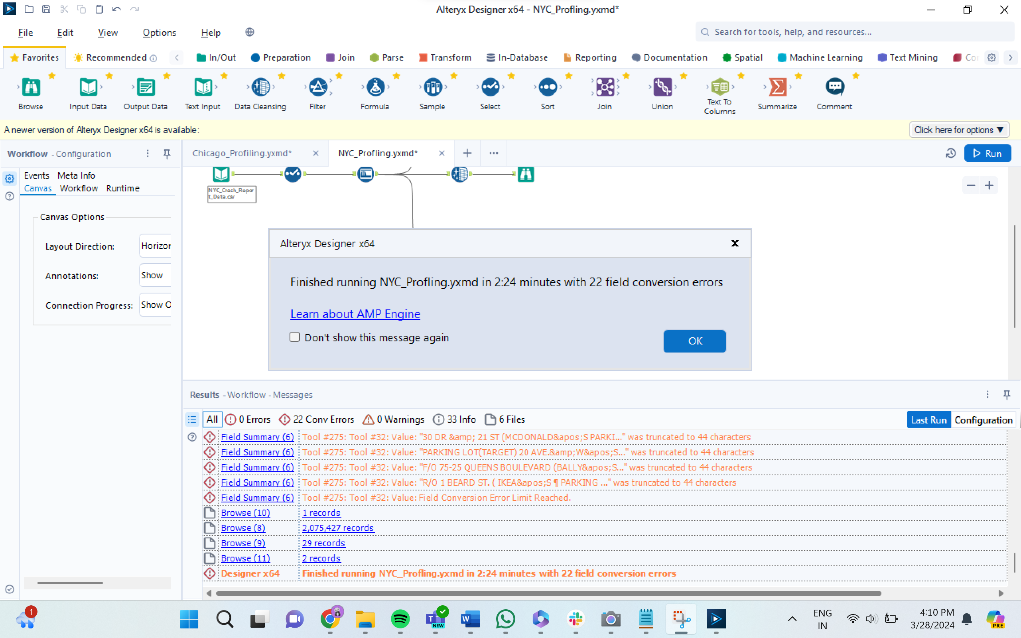

**REPORT:**

**Numeric Fields:**

|  |  |  |  |  |  |  |  |  |
| --- | --- | --- | --- | --- | --- | --- | --- | --- |
| **Name** | **% Missing** | **Unique Values** | **Min** | **Mean** | **Median** | **Max** | **Std Dev** | **Remarks** |
| longitude | 11.3% | 98,352 | -201.360 | -73.752 | -73.926 | 0.000 | 3.723 | This field has over 10% missing values. Consider imputing these values. |
| number of motorists killed | 0.0% | 6 | 0.000 | 0.001 | 0.000 | 5.000 | 0.027 | This field has a small number of unique values and appears to be a categorical field. Consider changing the field data type to "string". |
| number of persons killed | 0.0% | 8 | 0.000 | 0.001 | 0.000 | 8.000 | 0.041 | This field has a small number of unique values and appears to be a categorical field. Consider changing the field data type to "string". |
| latitude | 11.3% | 126,595 | 0.000 | 40.628 | 40.722 | 43.344 | 1.981 | This field has over 10% missing values. Consider imputing these values. |
| number of pedestrians killed | 0.0% | 4 | 0.000 | 0.001 | 0.000 | 6.000 | 0.028 | This field has a small number of unique values and appears to be a categorical field. Consider changing the field data type to "string". |
| number of cyclists injured | 0.0% | 5 | 0.000 | 0.027 | 0.000 | 4.000 | 0.163 | This field has a small number of unique values and appears to be a categorical field. Consider changing the field data type to "string". |
| number of cyclists killed | 0.0% | 3 | 0.000 | 0.000 | 0.000 | 2.000 | 0.011 | This field has a small number of unique values and appears to be a categorical field. Consider changing the field data type to "string". |
| number of persons injured | 0.0% | 33 | 0.000 | 0.310 | 1.000 | 43.000 | 0.700 |  |
| number of motorists injured | 0.0% | 31 | 0.000 | 0.223 | 0.000 | 43.000 | 0.661 |  |
| number of pedestrians injured | 0.0% | 14 | 0.000 | 0.057 | 0.000 | 27.000 | 0.244 |  |
| collision_id | 0.0% | 2,075,427 | 22.000 | 3,159,626.962 | 3,673,954.000 | 4,712,252.000 | 1,505,149.883 |  |

**String/Character Fields**

|  |  |  |  |  |  |  |  |
| --- | --- | --- | --- | --- | --- | --- | --- |
| **Name** | **% Missing** | **Unique Values** | **Shortest Value** | **Longest Value** | **Min Value Count** | **Max Value Count** | **Remarks** |
| crash time | 0.0% | 1,440 | 2:39 | 11:45 | 94 | 28,391 | Some values of this field have a small number of value counts. If Appropriate, consider combining some value levels together. |
| vehicle type code 1 | 0.7% | 1,635 | . | Enclosed Body – Non-removable Enclosure | 1 | 576,659 | Some values of this field have a small number of value counts. If Appropriate, consider combining some value levels together. |
| on street name | 21.2% | 13,081 |  | WILLIAMSBURG BRIDGE OUTER ROADWAY | 1 | 440,569 | This field has over 10% missing values. Consider imputing these values. Some values of this field have a small number of value counts. If Appropriate, consider combining some value levels together. |
| contributing  factor vehicle 4 | 98.4% | 42 | Glare | Traffic Control Device Improper/Non-Working | 1 | 2,041,953 | This field has over 10% missing values. Consider imputing these values. Some values of this field have a small number of value counts. If Appropriate, consider combining some value levels together. |
| contributing factor vehicle 5 | 99.6% | 31 | Glare | Traffic Control Device Improper/Non-Working | 1 | 2,066,358 | This field has over 10% missing values. Consider imputing these values. Some values of this field have a small number of value counts. If Appropriate, consider combining some value levels together. |
| location | 11.3% | 283,007 | (0.0, 0.0) | (40.8359271, -73.9029039) | 1 | 233,626 | This field has over 10% missing values. Consider imputing these values. Some values of this field have a small number of value counts. If Appropriate, consider combining some value levels together. |
| contributing factor vehicle 2 | 15.5% | 62 | 1 | Pedestrian/Bicyclist/Other Pedestrian Error/Confusion | 3 | 1,476,469 | This field has over 10% missing values. Consider imputing these values. Some values of this field have a small number of value counts. If Appropriate, consider combining some value levels together. |
| vehicle type code 5 | 99.6% | 71 | C3 | Station Wagon/Sport Utility Vehicle | 1 | 2,066,635 | This field has over 10% missing values. Consider imputing these values. Some values of this field have a small number of value counts. If Appropriate, consider combining some value levels together. |
| off street name | 83.2% | 200,266 |  | 26-45 Brooklyn queen’s expressway wes | 1 | 1,727,231 | This field has over 10% missing values. Consider imputing these values. Some values of this field have a small number of value counts. If Appropriate, consider combining some value levels together. |
| vehicle type code 4 | 98.4% | 102 | PK | Station Wagon/Sport Utility Vehicle | 1 | 2,043,115 | This field has over 10% missing values. Consider imputing these values. Some values of this field have a small number of value counts. If Appropriate, consider combining some value levels together. |
| cross street name | 37.8% | 13,699 |  | CROSS BRONX EXPRESSWAY EXTENSION | 1 | 784,436 | This field has over 10% missing values. Consider imputing these values. Some values of this field have a small number of value counts. If Appropriate, consider combining some value levels together. |
| crash date | 0.0% | 4,283 | 09/11/2021 | 09/11/2021 | 94 | 1,161 | Some values of this field have a small number of value counts. If Appropriate, consider combining some value levels together. |
| contributing factor vehicle 3 | 92.9% | 52 | 1 | Pedestrian/Bicyclist/Other Pedestrian Error/Confusion | 1 | 1,927,163 | This field has over 10% missing values. Consider imputing these values. Some values of this field have a small number of value counts. If Appropriate, consider combining some value levels together. |
| vehicle type code 3 | 93.1% | 263 | PK | Station Wagon/Sport Utility Vehicle | 1 | 1,932,528 | This field has over 10% missing values. Consider imputing these values. Some values of this field have a small number of value counts. If Appropriate, consider combining some value levels together. |
| borough | 31.1% | 6 | BRONX | STATEN ISLAND | 60,012 | 645,746 | This field has over 10% missing values. Consider imputing these values. Some values of this field have a small number of value counts. If Appropriate, consider combining some value levels together. |
| contributing factor vehicle 1 | 0.3% | 62 | 1 | Pedestrian/Bicyclist/Other Pedestrian Error/Confusion | 10 | 706,732 | Some values of this field have a small number of value counts. If Appropriate, consider combining some value levels together. |
| vehicle type code 2 | 19.1% | 1,824 | 0 | Enclosed Body - Nonremovable Enclosure | 1 | 403,529 | This field has over 10% missing values. Consider imputing these values. Some values of this field have a small number of value counts. If Appropriate, consider combining some value levels together. |
| zip code | 31.1% | 236 |  | 11208 | 1 | 645,996 | This field has over 10% missing values. Consider imputing these values. Some values of this field have a small number of value counts. If Appropriate, consider combining some value levels together. |

DIMENSIONAL MODEL:

**HOW DOES THE DIMENSIONAL MODEL ANSWER THE BUSINESS QUESTIONS:**  
**~ How many accidents occurred in NYC, Austin, and Chicago?**

In the dimensional model, the Fct_Accident fact table holds records of individual accidents, including details about each incident's outcome, such as injuries and fatalities. The Dim_Location table contains attributes such as City, StreetName, and Latitude/Longitude, which allow us to filter and count accidents based on the city. By joining Fct_Accident with Dim_Location on the LocationKey and grouping the results by the city attribute, we can determine the number of accidents for each specified city.

**~ Best way to present these values on the dashboard:**  
For visual representation on a dashboard, a bar chart is effective for comparing the number of accidents across cities. Alternatively, a map visualization with pins or heatmaps can provide a geographical context, making it immediately apparent which cities have higher accident rates.

**~ Which areas in the 3 cities had the greatest number of accidents?**Using the Dim_Location table, we can identify specific areas with the highest accidents by grouping accident data by City and AreaName (if this attribute is captured in the location dimension) or by other geographic identifiers available. Sorting these groups by the count of related accidents in descending order and then selecting the top three will give us the areas with the greatest number of accidents in each city.

**~How many accidents resulted in just injuries?**  
To find accidents that resulted only in injuries, we would use the Fct_Accident fact table and filter records where InjuriesCount is greater than zero and FatalitiesCount is zero. We can then aggregate this data to get a total count for the overall report and group by City for the city-level report.

**~ How often are pedestrians involved in accidents?**  
To determine the frequency of pedestrian involvement, we can sum the PedestriansInvolvedCount from the Fct_Accident table. For an overall count, sum this value across all records. For city-level data, perform the same sum but group the results by the City field from the Dim_Location table.

**~ When do most accidents happen? (Seasonality report)**For the seasonality report, you will need to join Fct_Accident with the Dim_Date table on the relevant date key. Then, you can aggregate accident counts based on the Month or Season fields. This will reveal patterns or trends indicating when accidents are most frequent, such as particular seasons or months of the year.

**~ How many motorists are injured or killed in accidents?**  
By referencing the MotoristsInjuredCount and MotoristsKilledCount in the Fct_Accident table, we can sum these figures for the overall statistics. To break down the numbers by city, you would perform the sum within groups determined by joining with Dim_Location on the LocationKey and grouping by City.

**~ Which top 5 areas in 3 cities have the most fatal number of accidents?**  
This requires analyzing the FatalitiesCount from the Fct_Accident table. By joining with the Dim_Location table and grouping by location-related attributes, you can sort the results by the number of fatalities in descending order. Limiting the result set to the top five will provide the areas with the most fatal accidents.

**~ Time-based analysis of accidents:**  
Join Fct_Accident with Dim_Time on TimeKey and then group and count the accidents by different time dimensions such as Hour, Weekday vs. Weekend, and Time (morning, afternoon, evening). This will allow you to analyze and visualize the data to understand accident patterns relative to the time of day or week.

**~ Fatality analysis:**   
Comparing pedestrian fatalities to those of motorists involves aggregating PedestriansKilledCount and comparing it against MotoristsKilledCount from the Fct_Accident table. Additionally, comparing these numbers to the total FatalitiesCount will indicate which group is more at risk.

**~ What are the most common factors involved in accidents?**  
This can be ascertained by analyzing the Dim_ContributingFactors dimension table. By joining this table with the BridgeContributingFactorAccident table, which relates contributing factors to specific accidents, and then counting the frequency of each contributing factor, you can identify which are most common in accidents.

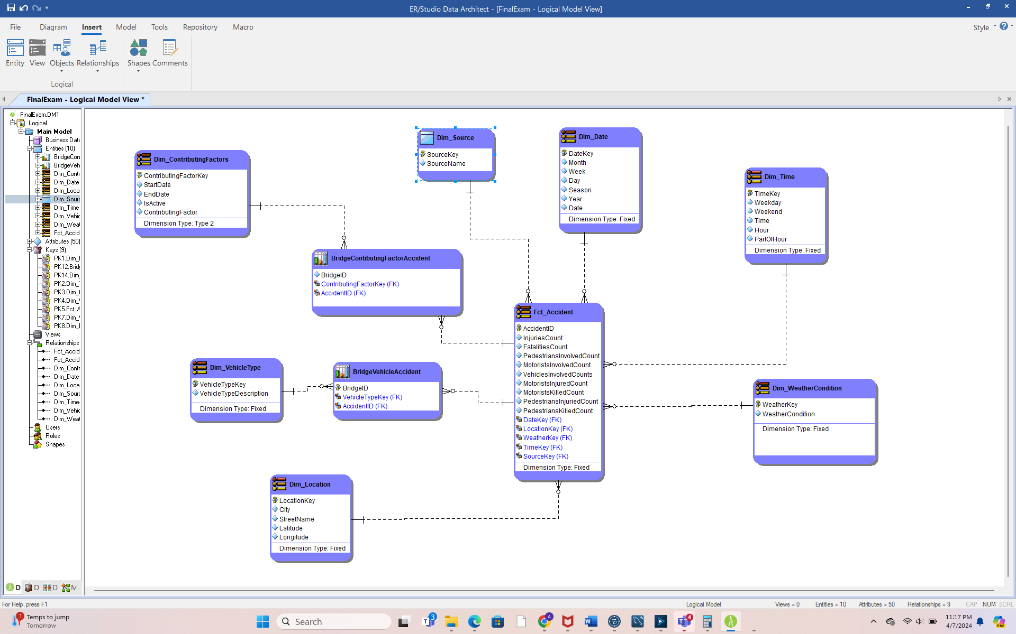

**CONTRIBUTING FACTORS MAPPING DOCUMENT:**

Took the codes and descriptions from the Contributing Factors Mapping document provided in One drive and performed a VLOOKUP with the normalized contributory cause columns and created separate csv sheets for each dataset. Used these csv sheets as input with the final normalized table to map code with the contributory cause.

* AUSTIN:



* CHICAGO:

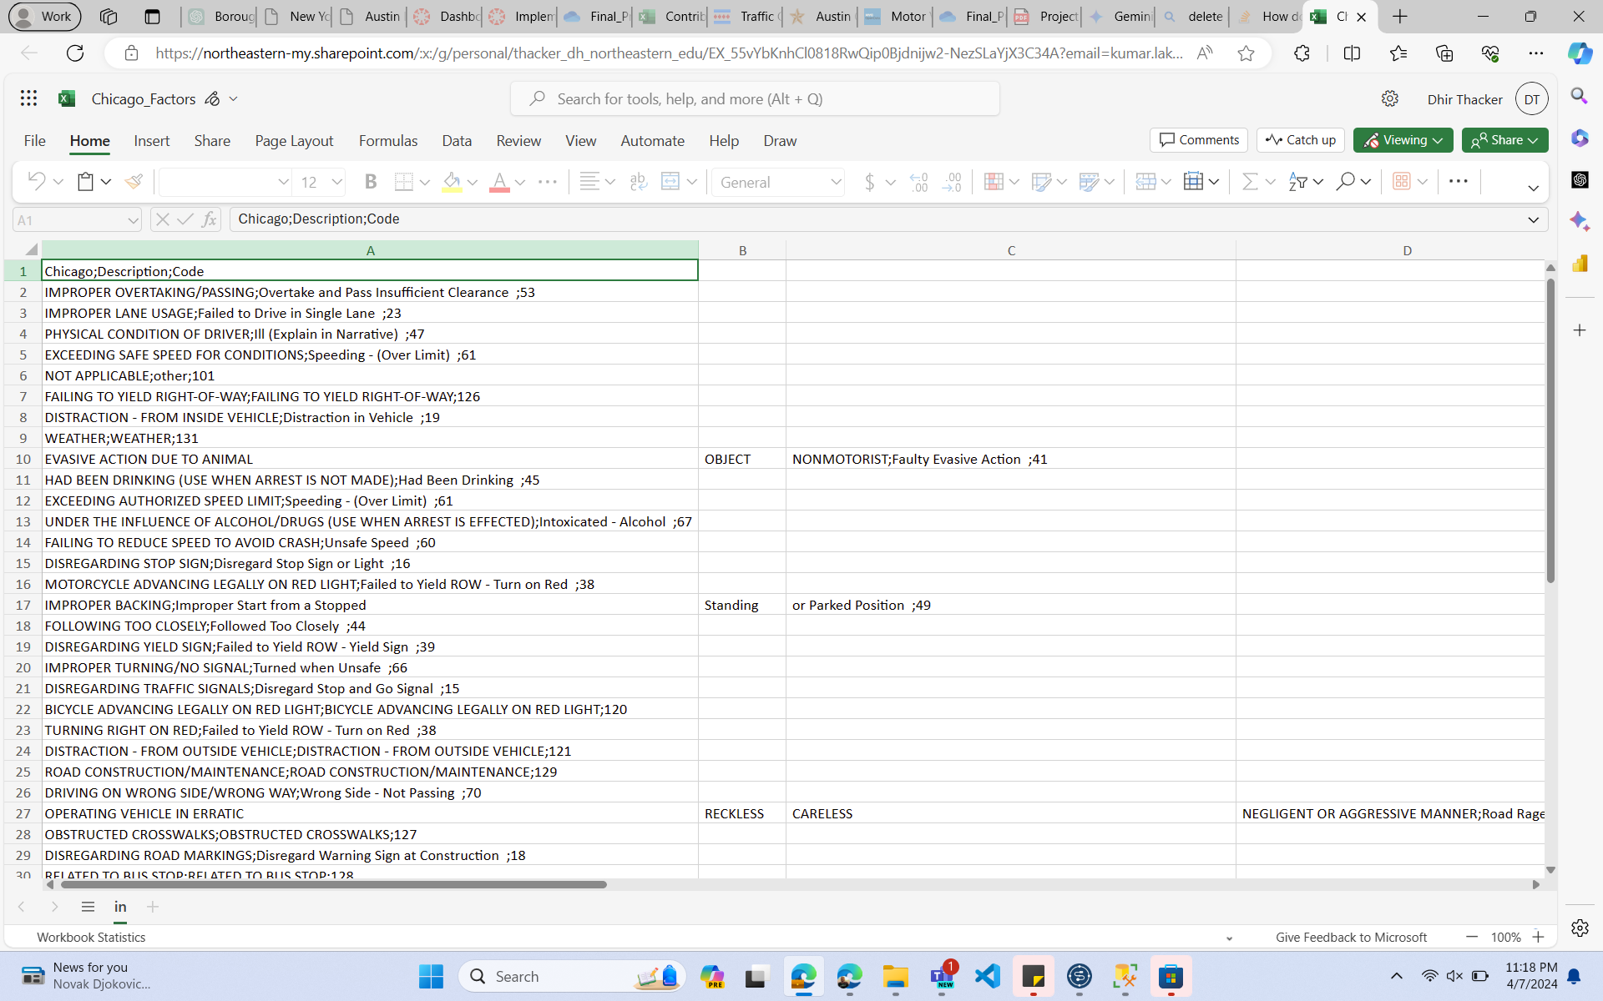

* NYC:

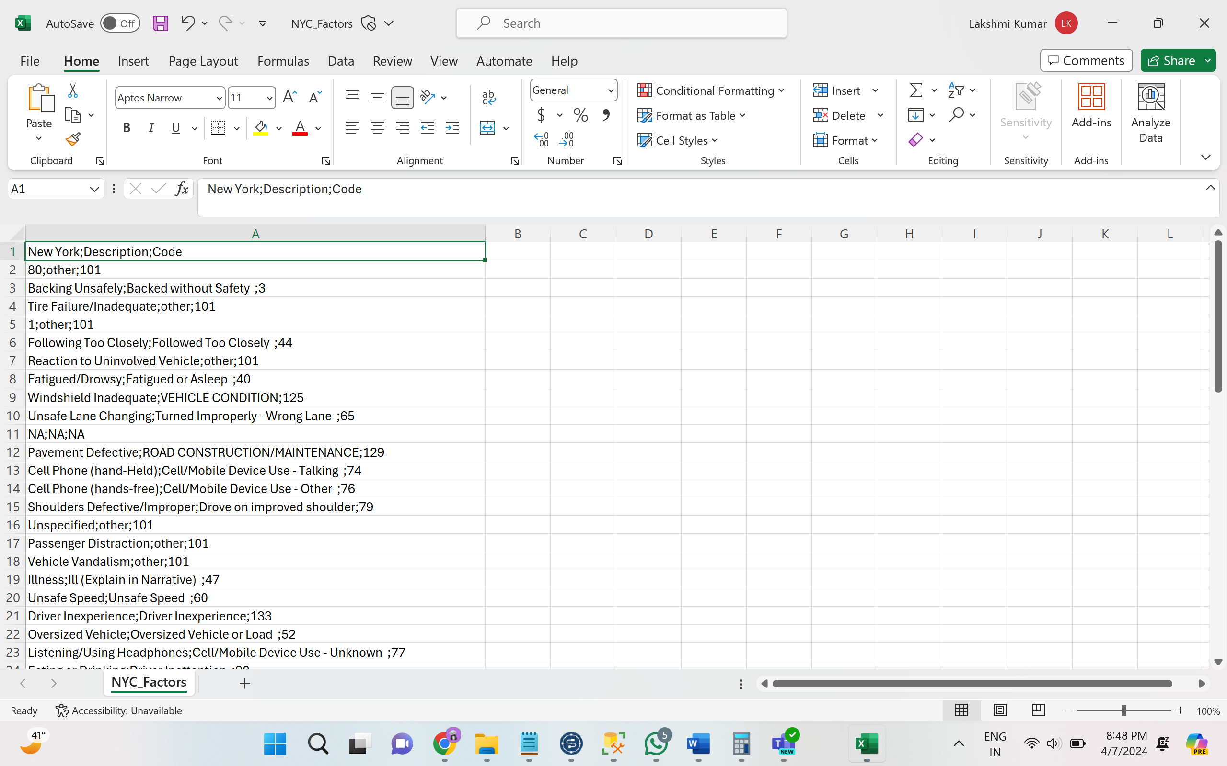

BASIC STAGING OF ALL THREE DATASET USING TALEND:

* AUSTIN

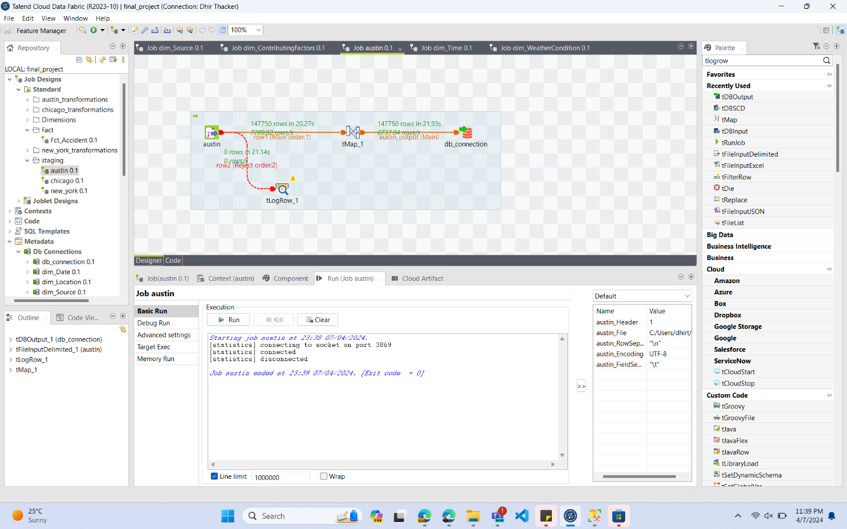

* CHICAGO

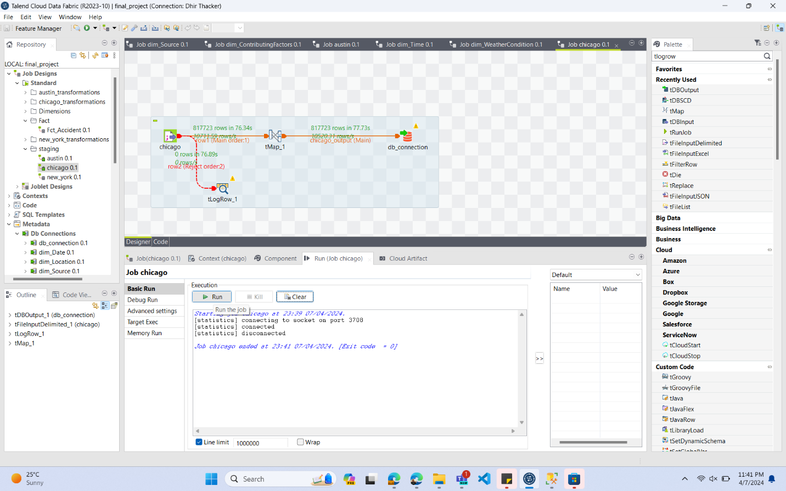

* NYC

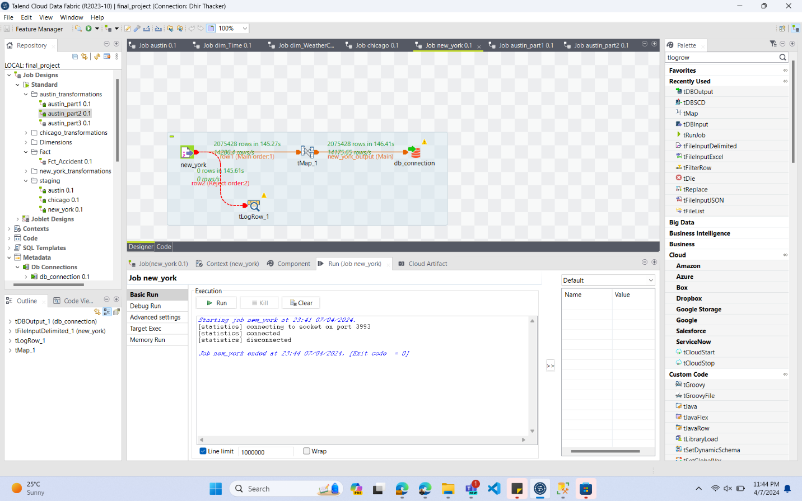

**TRANSFORMATIONS PART 1:**

Removing columns that are not required for the business questions and handling null values till contributing_factors column.

* AUSTIN

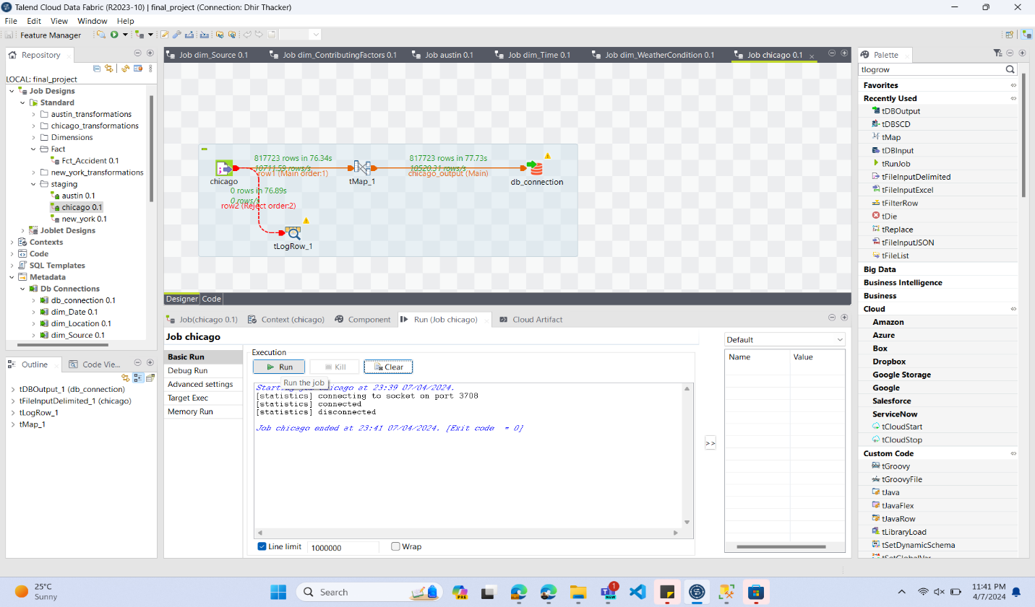

* CHICAGO

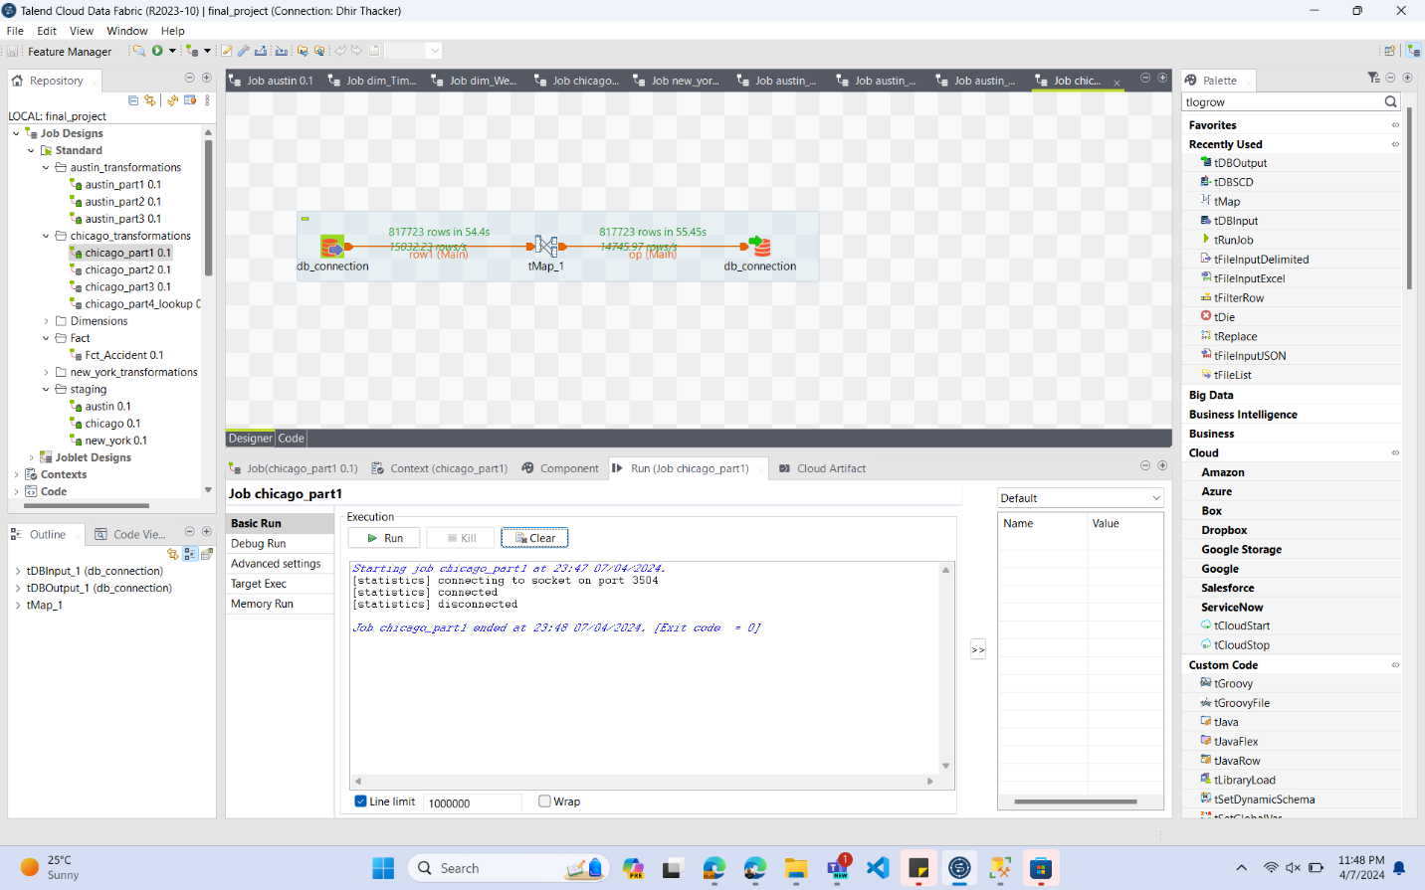

* NYC

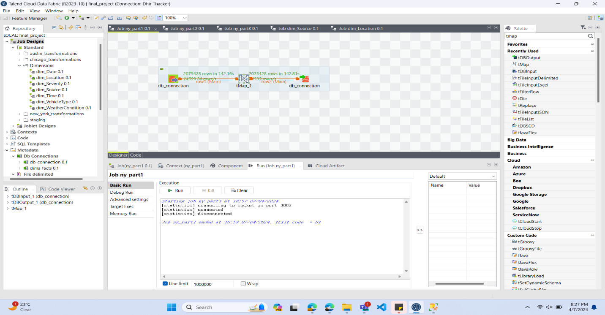

TRANSFORMATIONS PART 2 CONTRIBUTING FACTORS

Handling null values and merging contributing factors column and eventually normalizing it.

* AUSTIN

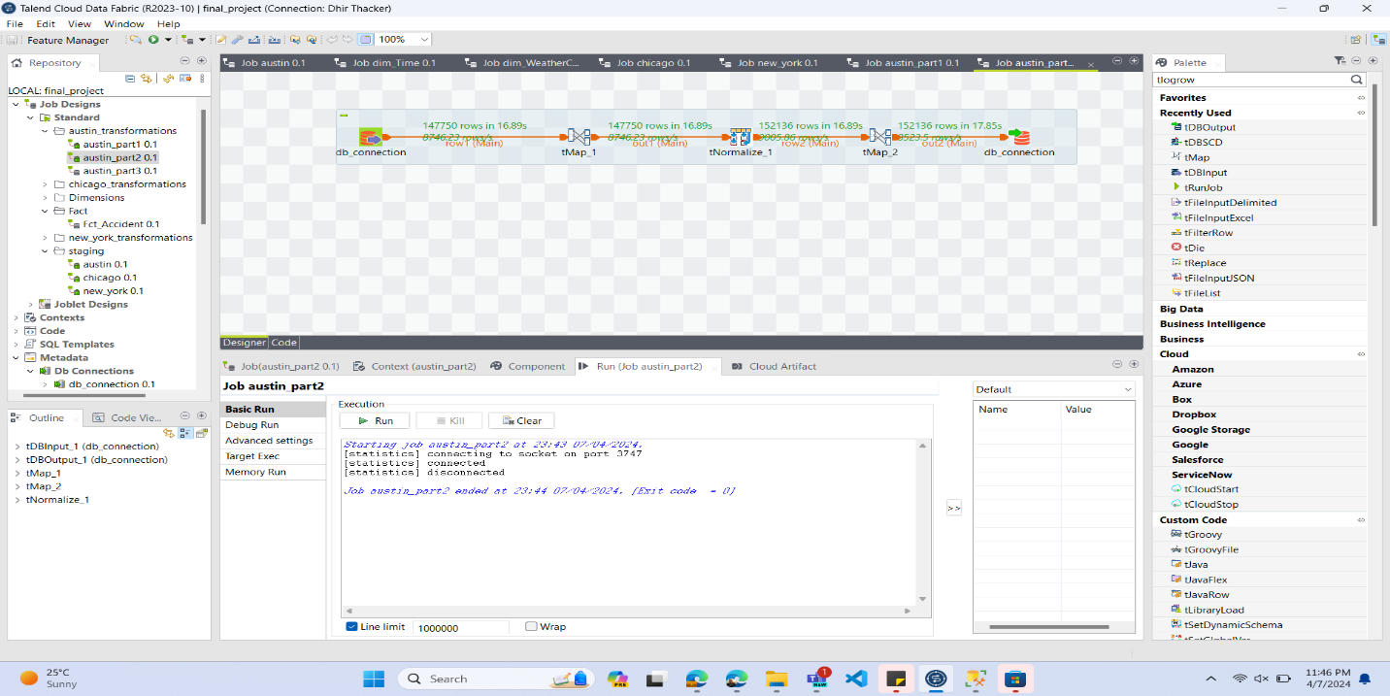

* CHICAGO

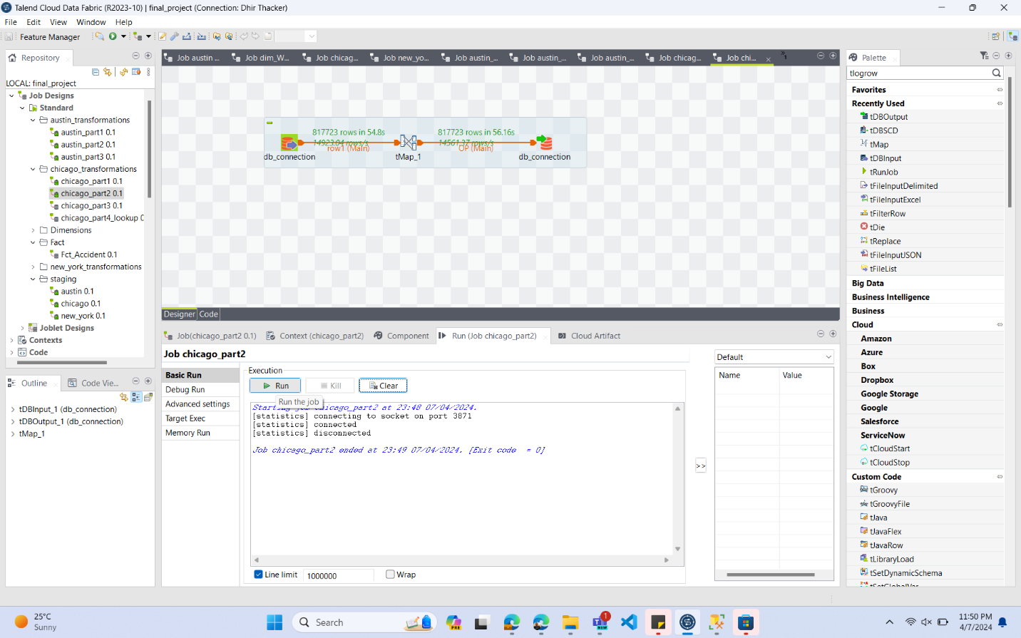

* NYC

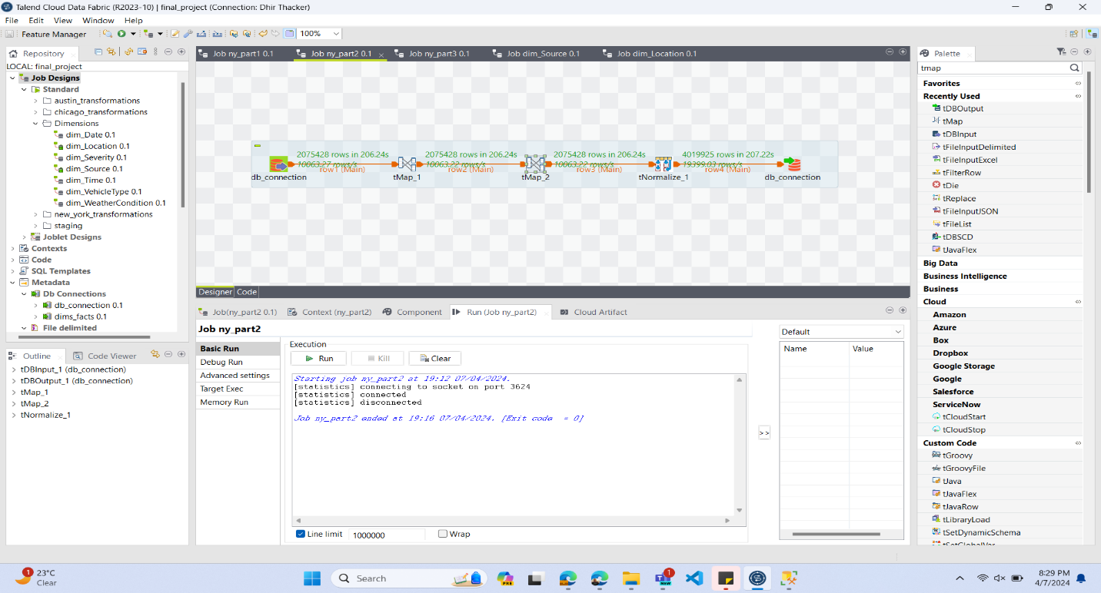

TRANSFORMATIONS PART 3

Handling null values, combining columns and normalizing

* AUSTIN

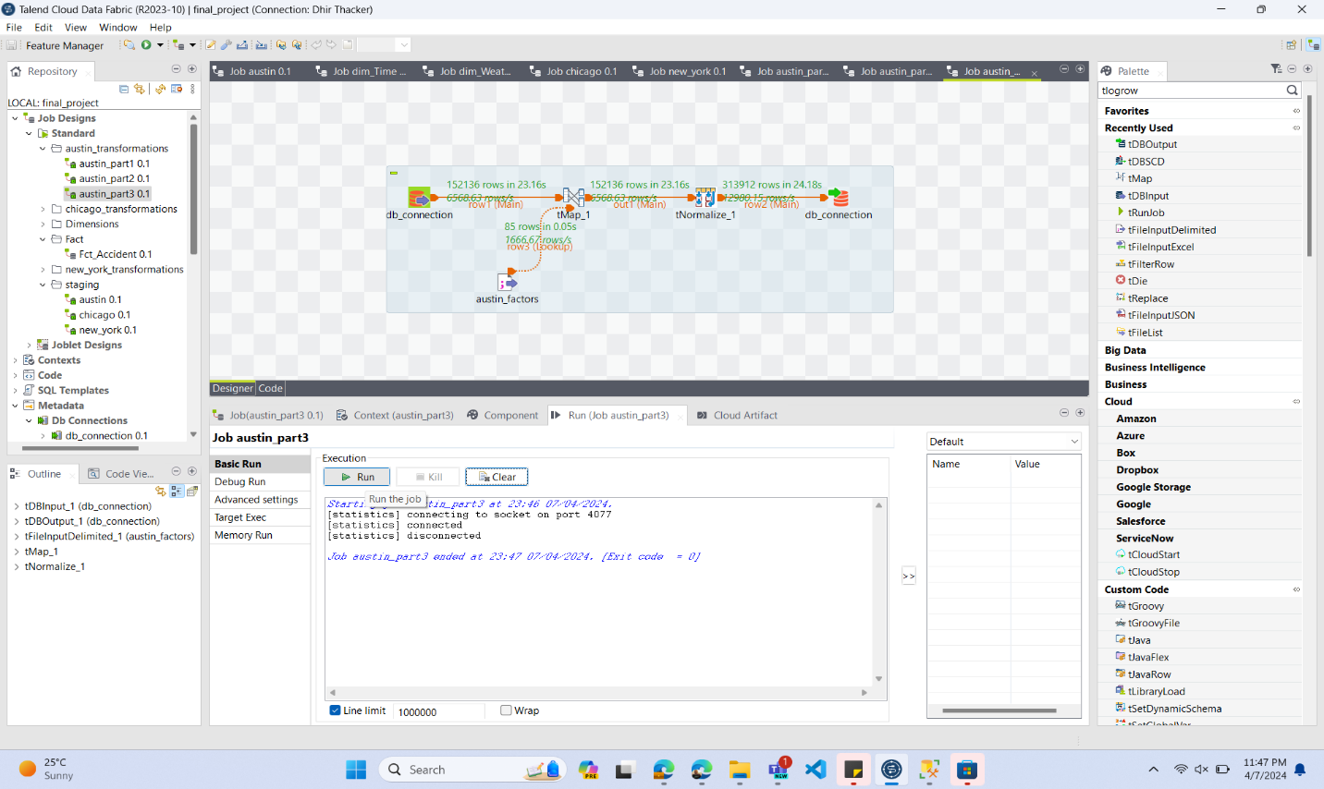

* CHICAGO

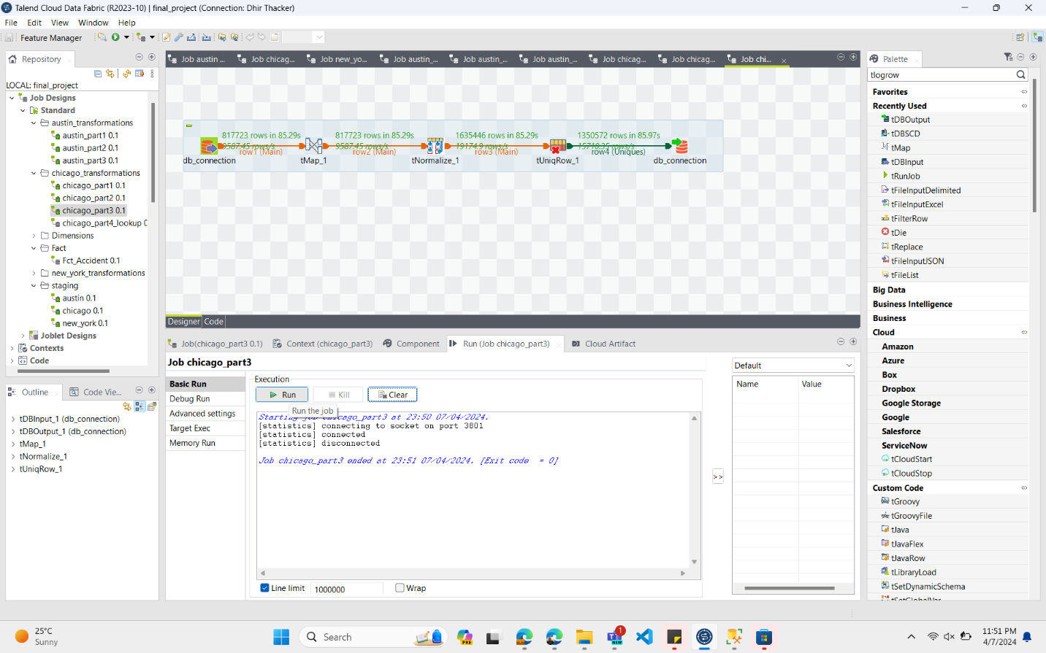

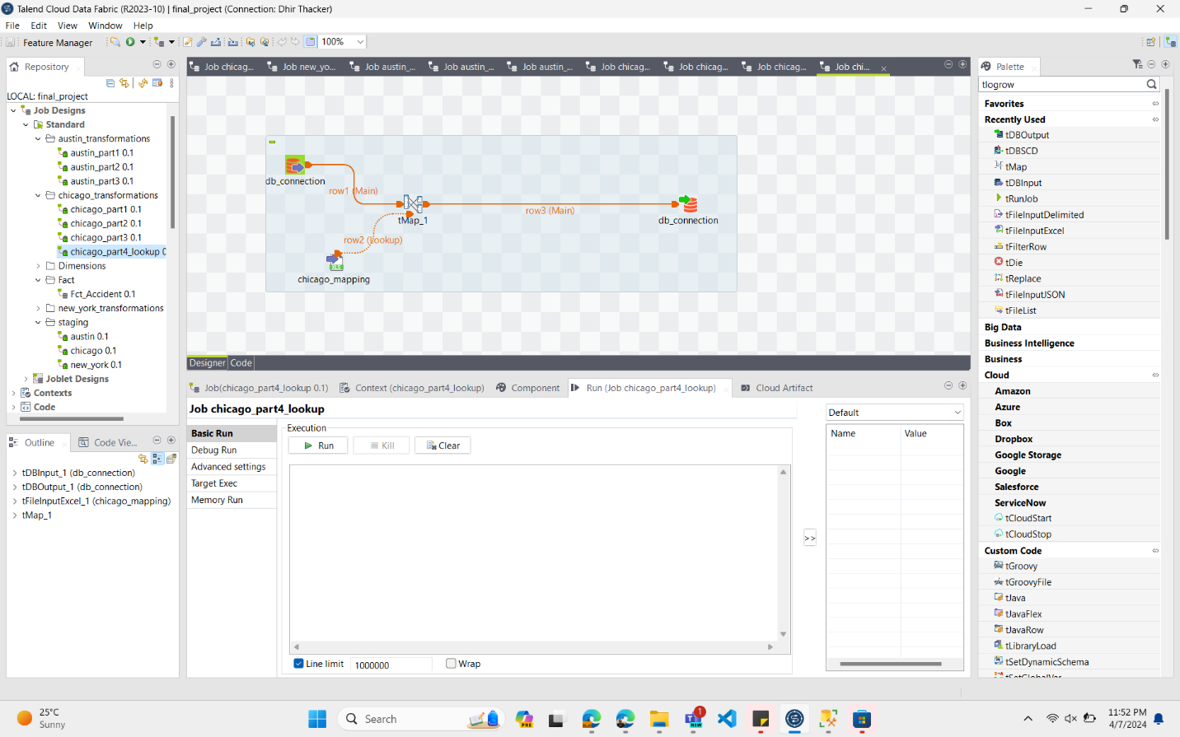

* NYC

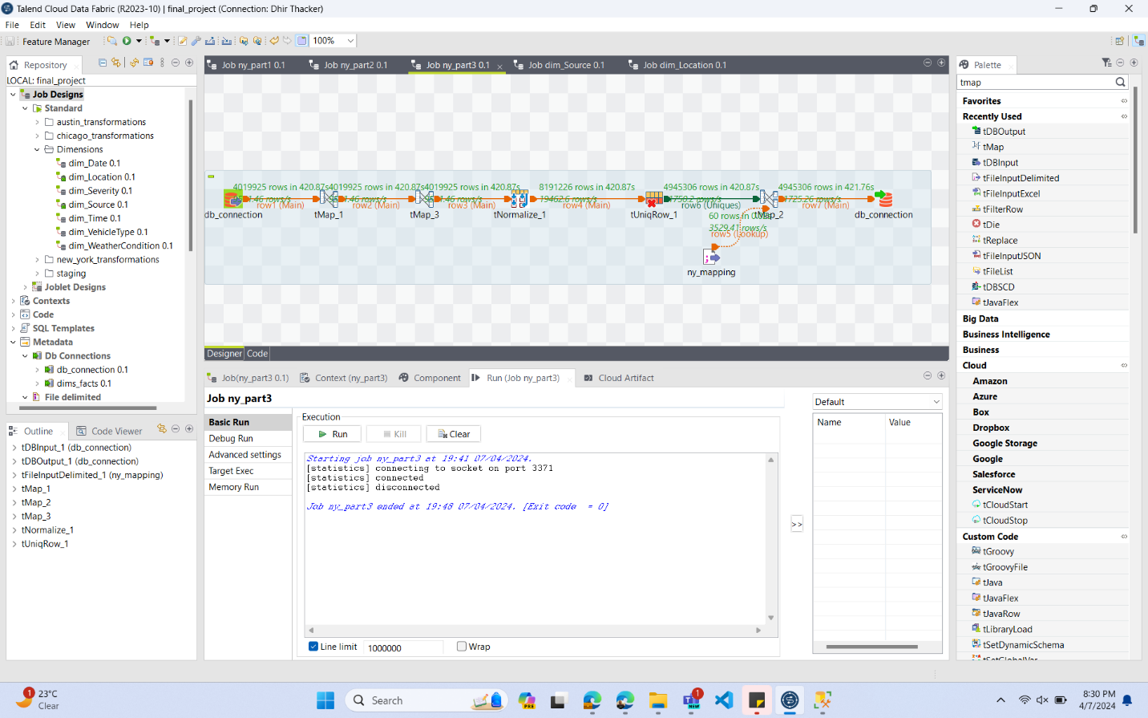

LOADING INTO FACT TABLE AND DIMS

1) Dim_Location

TALEND JOB:

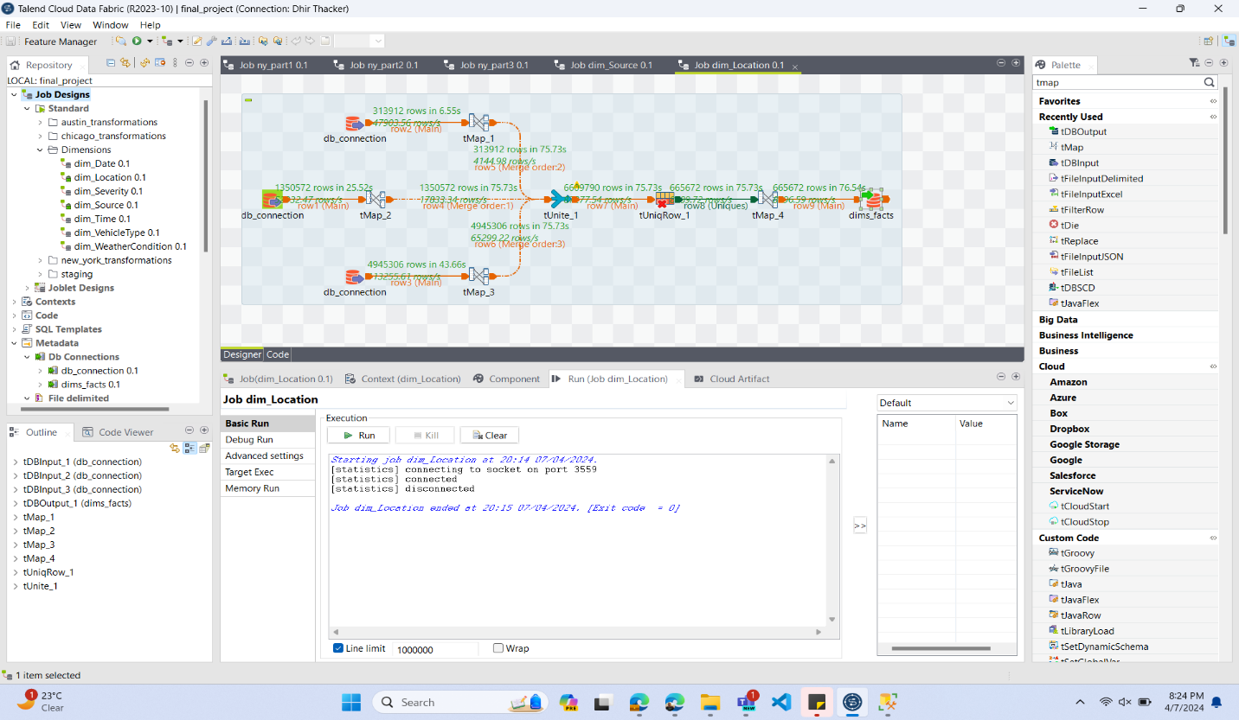

2) Dim_Source

TALEND JOB:

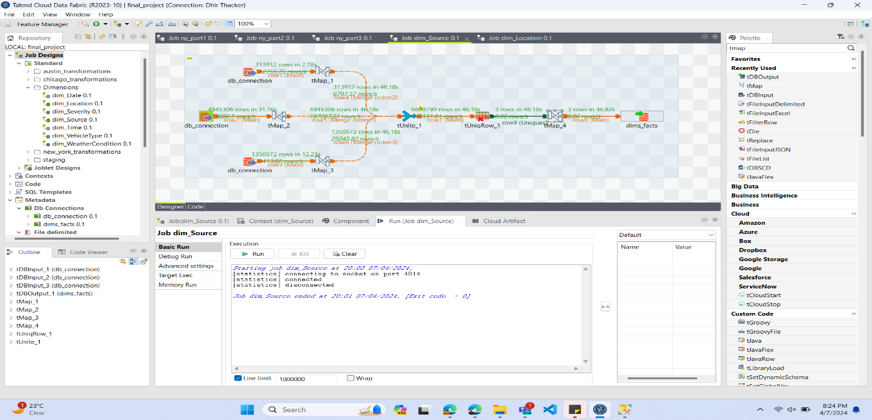

3)Dim_Date

TALEND JOB:

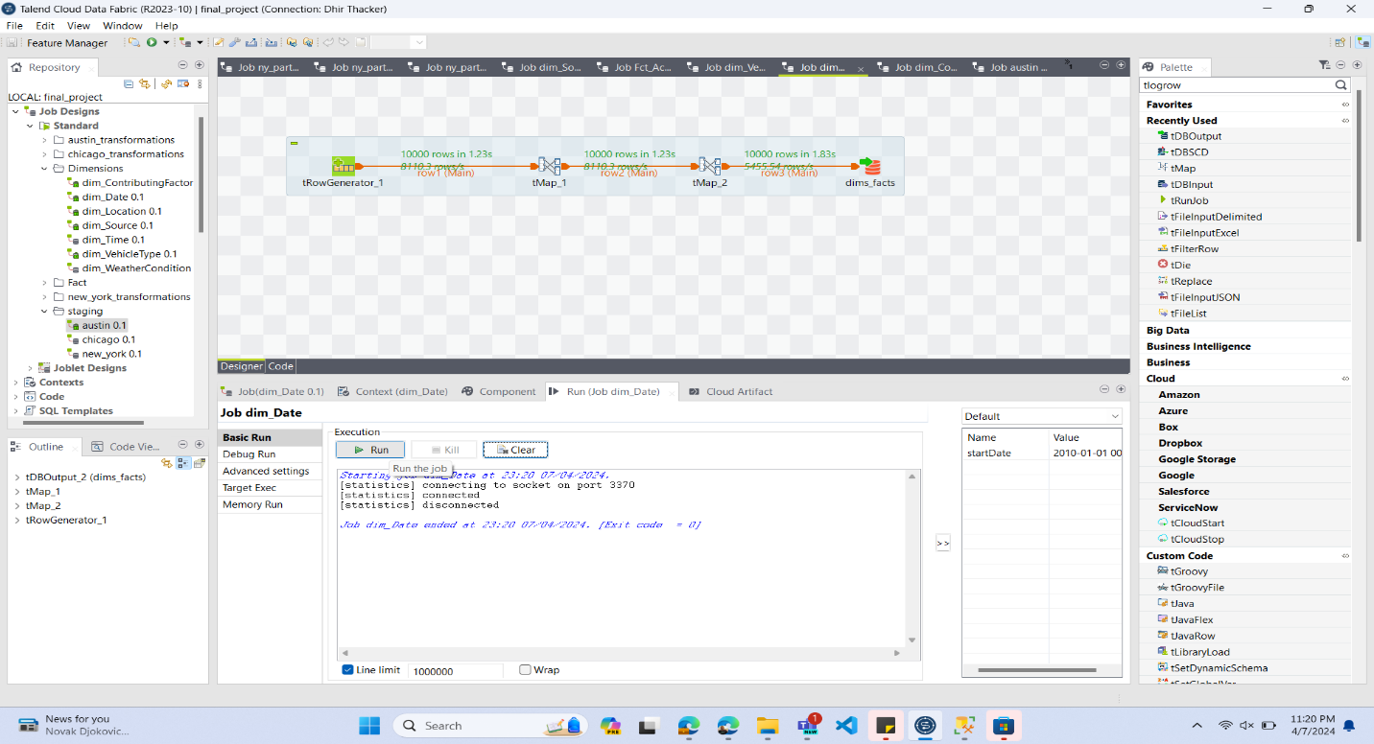

4)Dim_Time

TALEND JOB:

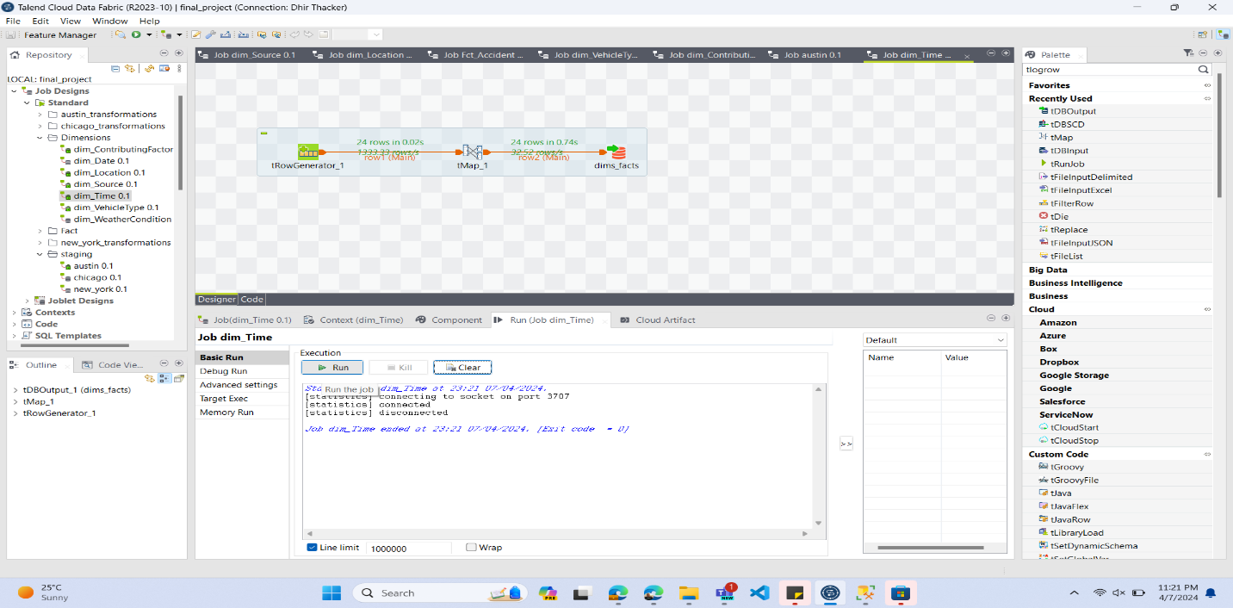

5)Dim_VehicleType

TALEND JOB:

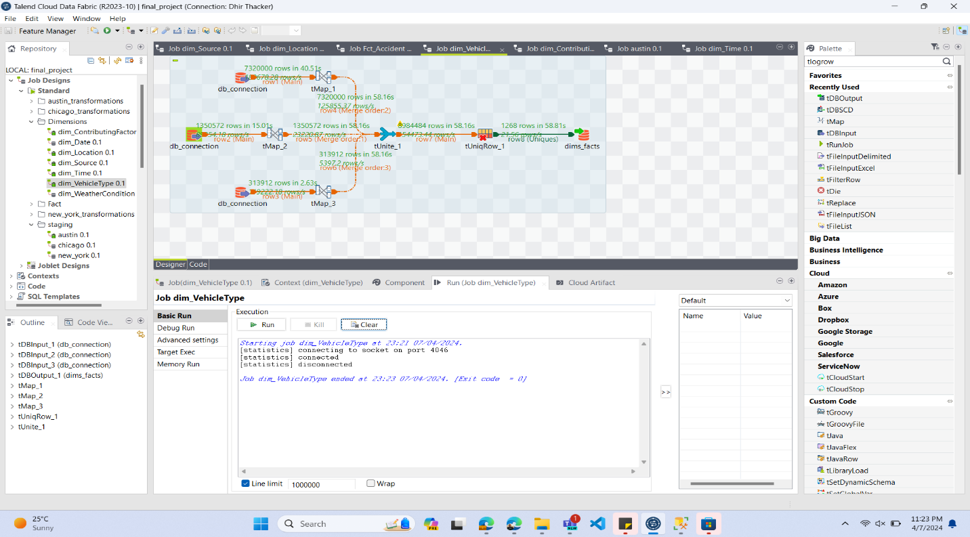

6)Dim_WeatherCondition

TALEND JOB:

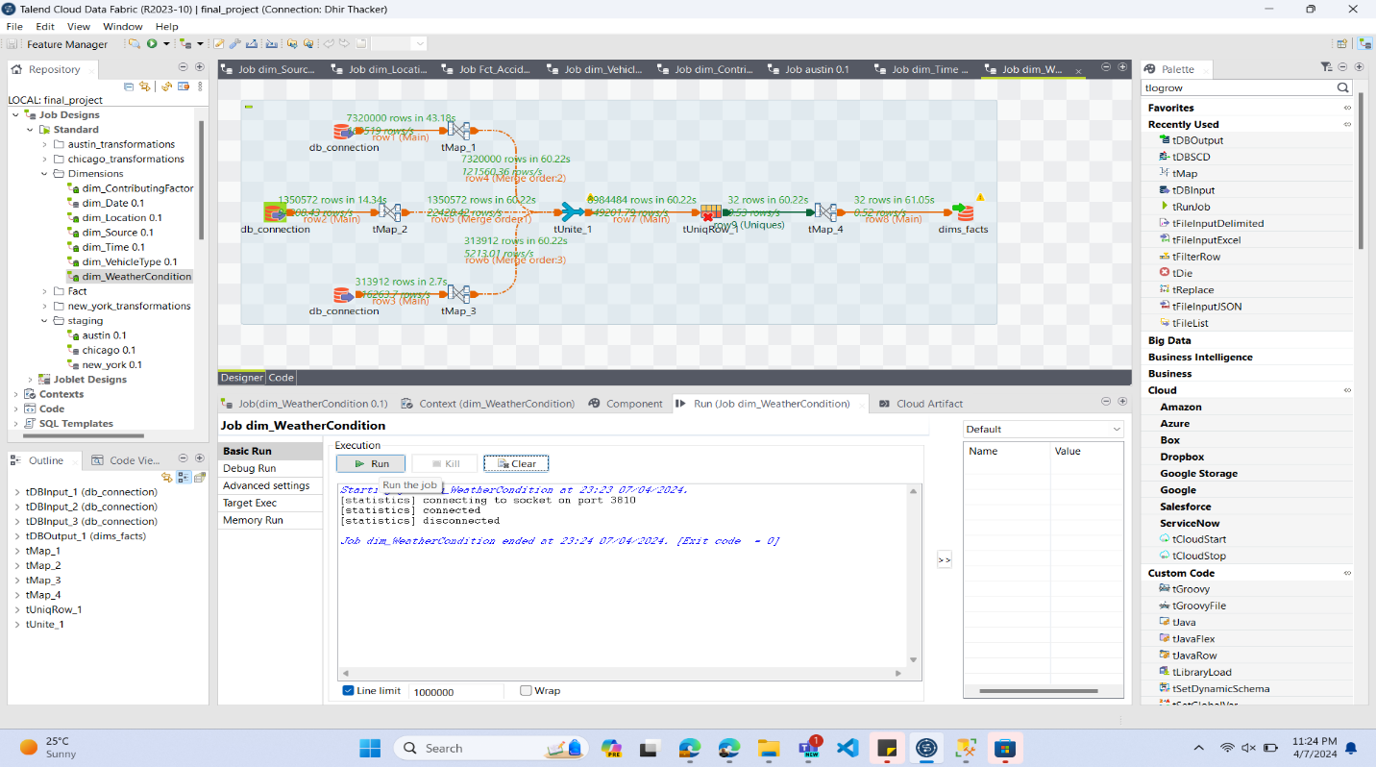

7) Fct_Accident

TALEND JOB:

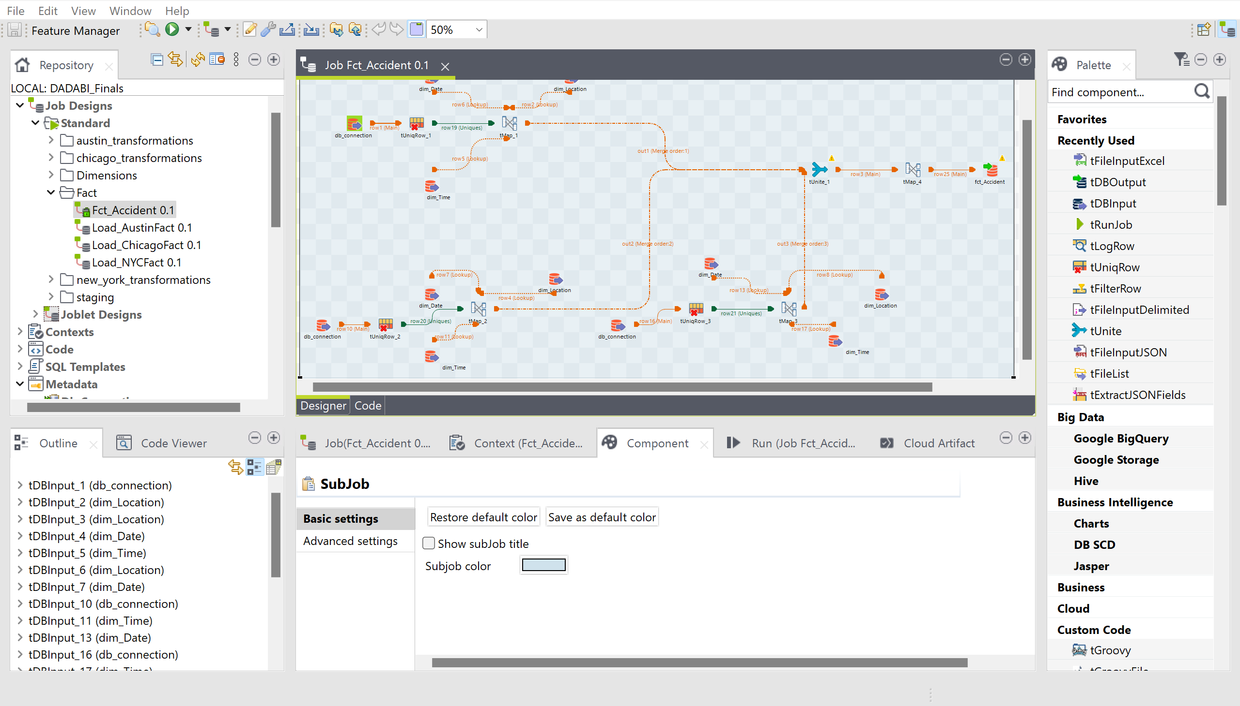

8) Dim_ContributingFactors

TALEND JOB:

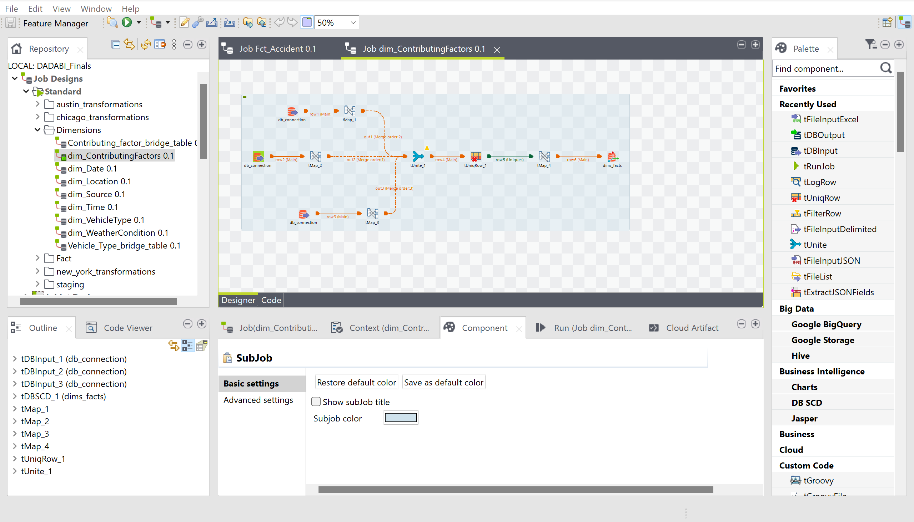

9) Contributing Factors Bridge Table

TALEND JOB:

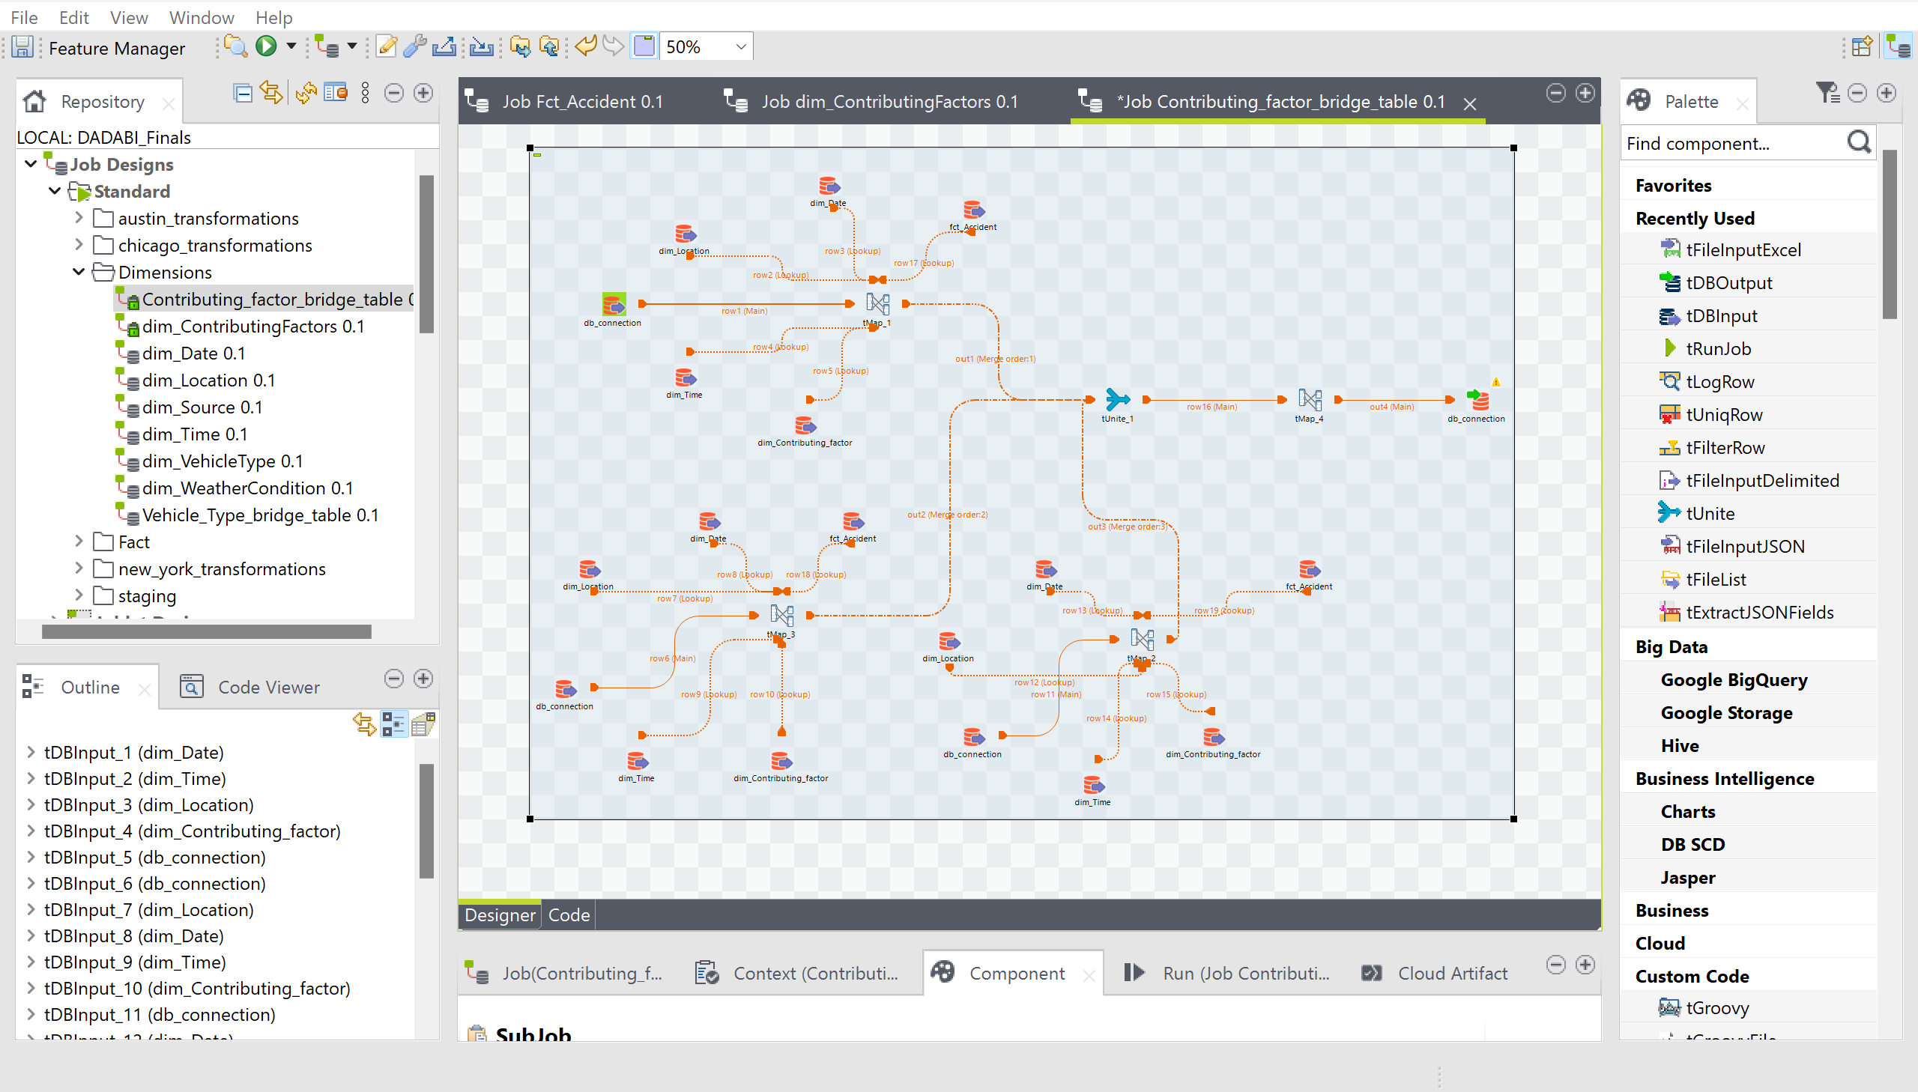

10) Vehicle Type Bridge Table

TALEND JOB:

